UNITED STATES
SECURITIES AND EXCHANGE COMMISSION
Washington, D.C. 20549

FORM 8-K

CURRENT REPORT
Pursuant to Section 13 or 15(d) of the Securities Exchange Act of 1934
Date of Report (Date of earliest event reported): July 30, 2026

Commission  File Number | Registrant; State of Incorporation  Address; and Telephone Number | I.R.S. Employer  Identification No.
1-5324 | EVERSOURCE ENERGY  (a Massachusetts voluntary association)  300 Cadwell Drive  Springfield, Massachusetts 01104  Telephone: (800) 286-5000 | 04-2147929
0-00404 | THE CONNECTICUT LIGHT AND POWER COMPANY  (a Connecticut corporation)  107 Selden Street  Berlin, Connecticut 06037-1616  Telephone: (800) 286-5000 | 06-0303850
1-02301 | NSTAR ELECTRIC COMPANY  (a Massachusetts corporation)  800 Boylston Street  Boston, Massachusetts 02199  Telephone: (800) 286-5000 | 04-1278810
1-6392 | PUBLIC SERVICE COMPANY OF NEW HAMPSHIRE  (a New Hampshire corporation)  Energy Park  780 North Commercial Street  Manchester, New Hampshire 03101-1134  Telephone: (800) 286-5000 | 02-0181050

Not Applicable
(Former name or former address, if changed since last report)

Check the appropriate box below if the Form 8-K filing is intended to simultaneously satisfy the filing obligation of the registrant under any of the following provisions (see General Instruction A.2. below):

 | ☐ | Written communications pursuant to Rule 425 under the Securities Act (17 CFR 230.425)

 | ☐ | Soliciting material pursuant to Rule 14a-12 under the Exchange Act (17 CFR 240.14a-12)

 | ☐ | Pre-commencement communications pursuant to Rule 14d-2(b) under the Exchange Act (17 CFR 240.14d-2(b))

 | ☐ | Pre-commencement communications pursuant to Rule 13e-4(c) under the Exchange Act (17 CFR 240.13e-4(c))

Securities registered pursuant to Section 12(b) of the Act:

Registrant | Title of each class | Trading  Symbol(s) | Name of each exchange on  which registered
Eversource Energy | Common Shares, $5.00 par value per share | ES | New York Stock Exchange

Indicate by check mark whether the registrant is an emerging growth company as defined in Rule 405 of the Securities Act of 1933 (§230.405 of this chapter) or Rule 12b-2 of the Securities Exchange Act of 1934 (§240.12b-2 of this chapter).

Emerging growth
company
Eversource Energy | ☐
The Connecticut Light and Power Company | ☐
NSTAR Electric Company | ☐
Public Service Company of New Hampshire | ☐

If an emerging growth company, indicate by check mark if the registrant has elected not to use the extended transition period for complying with any new or revised financial accounting standards provided pursuant to Section 13(a) of the Exchange Act.

Eversource Energy | ☐
The Connecticut Light and Power Company | ☐
NSTAR Electric Company | ☐
Public Service Company of New Hampshire | ☐

Document Type | 8-K
Document Period End Date | 2026-07-30
Amendment Flag | false
CIK | 0000023426
THE CONNECTICUT LIGHT_Written communications | ☐
THE CONNECTICUT LIGHT_Soliciting material pursuant to | ☐
THE CONNECTICUT LIGHT_Pre-commencement communications pursuant | ☐
THE CONNECTICUT LIGHT_Pre-commencement communications pursuant | ☐
Document Type | 8-K
Document Period End Date | 2026-07-30
Amendment Flag | false
CIK | 0000013372
NSTAR ELECTRIC_Written communications | ☐
NSTAR ELECTRIC_Soliciting material pursuant to | ☐
NSTAR ELECTRIC_Pre-commencement communications pursuant | ☐
NSTAR ELECTRIC_Pre-commencement communications pursuant | ☐
CIK | 0000315256
Public Service Company_Written communications | ☐
Document Type | 8-K
Document Period End Date | 2026-07-30
Amendment Flag | false
Public Service Company_Soliciting material pursuant to | ☐
Public Service Company_Pre-commencement communications pursuant | ☐
Public Service Company_Pre-commencement communications pursuant | ☐

 | Section 2 | Financial Information

 | Item 2.02 | Results of Operations and Financial Conditions.

On July 30, 2026, Eversource Energy issued a news release announcing its unaudited results of operations for the second quarter and first six months ended June 30, 2026, and related financial information for certain of its subsidiaries as of and for the same period. A copy of the news release and related unaudited financial report are attached as Exhibits 99.1 and 99.2, respectively, and are incorporated herein by reference thereto.

The information contained in this Item 2.02, including Exhibits 99.1 and 99.2, shall not be deemed “filed” with the Securities and Exchange Commission (“SEC”) nor incorporated by reference in any registration statement filed by Eversource Energy or any subsidiary thereof under the Securities Act of 1933, as amended (the “Securities Act”), unless specified otherwise.

 | Section 7 | Regulation FD

 | Item 7.01 | Regulation FD Disclosure.

On July 31, 2026, Eversource Energy will webcast a conference call with financial analysts during which senior management will discuss the company’s financial performance through the second quarter of 2026. The webcast will be accessible through Eversource Energy's website at www.eversource.com or directly on the Investor Relations website at investors.eversource.com. Attached as Exhibit 99.3 and incorporated herein by reference are the slides to be discussed by Eversource Energy during the conference call.

The information contained in this Item 7.01, including Exhibit 99.3, shall not be deemed “filed” with the SEC nor incorporated by reference into any registration statement filed by Eversource Energy or any subsidiary thereof under the Securities Act, unless specified otherwise.

 | Section 9 | Financial Statements and Exhibits

 | Item 9.01 | Financial Statements and Exhibits.

Exhibit  Number | Description
99.1 | News Release of Eversource Energy dated July 30, 2026.
99.2 | Financial report for the three and six months ended June 30, 2026.
99.3 | July 31, 2026 presentation slides.
104 | Cover Page Interactive Data File (embedded within the Inline XBRL document).

SIGNATURE

Pursuant to the requirements of the Securities Exchange Act of 1934, the registrants have duly caused this report to be signed on their behalf by the undersigned hereunto duly authorized.

EVERSOURCE ENERGY
THE CONNECTICUT LIGHT AND POWER COMPANY
NSTAR ELECTRIC COMPANY
PUBLIC SERVICE COMPANY OF NEW HAMPSHIRE
(Registrants)
July 30, 2026 | By: | /s/ Jay S. Buth
 |  | Jay S. Buth
 |  | Vice President, Controller and Chief Accounting Officer

Exhibit 99.1



Eversource Energy Reports Second Quarter 2026 Results

HARTFORD, Conn. and BOSTON, Mass. (July 30, 2026) – Eversource Energy (“Eversource” or the “Company”) (NYSE: ES) today reported GAAP earnings of $53.7 million, or $0.14 per share, for the second quarter of 2026, compared with GAAP and non-GAAP earnings of $352.7 million, or $0.96 per share, for the second quarter of 2025. Non-GAAP recurring earnings totaled $329.1 million1, or $0.87 per share1, in the second quarter of 2026.

For the first half of 2026, Eversource reported GAAP earnings of $660.5 million, or $1.75 per share, compared with GAAP and non-GAAP earnings of $903.5 million, or $2.45 per share, for the first half of 2025. Non-GAAP recurring earnings totaled $979.8 million1, or $2.60 per share1, in the first half of 2026.

GAAP results for the second quarter and first half of 2026 include a non-cash, after-tax charge of $111.4 million, or $0.30 per share, related to the sale of Aquarion Water Company on June 30, 2026 and an after-tax charge of $164.0 million, or $0.43 per share, related to an increase in Eversource's offshore wind contingent liability for expected future payments to Global Infrastructure Partners as part of the September 30, 2024 sale of the South Fork Wind and Revolution Wind projects. GAAP results for the first half of 2026 include an after-tax charge of $43.9 million, or $0.12 per share, related to estimated refunds associated with the Federal Energy Regulatory Commission (FERC) decision of March 19, 2026, that reduced the return on equity (ROE) rate for New England transmission owners from 10.57% to 9.57%.

“During the second quarter, we completed our strategic divestiture of Aquarion Water, further strengthening our balance sheet and positioning Eversource for continued success as a pure-play regulated electric and natural gas delivery company. This focused strategy has already created new opportunities, including our preliminary selection by ISO-NE to develop critical transmission infrastructure that will bring power from northern Maine to southern New England. We are very pleased that the incumbent utilities have been selected for this important project.” said Joe Nolan, Chairman, President and CEO. “As we enter the second half of the year, our priorities remain clear: operating safely and efficiently, delivering reliable service to our customers, executing on our strategic investments and maintaining the financial strength that supports long-term value creation,” said Nolan.

The Company reaffirms its revised earnings guidance for 2026 non-GAAP recurring earnings of between $4.57 per share1 and $4.72 per share1, which includes the impact of the prospective reduction to the transmission ROE rate resulting from the March 2026 FERC order and the absence of Aquarion earnings in the second half of the year. It also reaffirms its cumulative long-term earnings per share growth rate within the range of 5 to 7 percent through 2030, using the adjusted 2026 non-GAAP earnings guidance midpoint of $4.65 per share1 as the base year. Eversource expects annual earnings growth towards the upper half of its long-term guidance by 2028.

Electric Transmission

Eversource Energy’s transmission segment, excluding the FERC ROE refund charge noted above, earned $183.7 million in the second quarter of 2026 and $408.0 million1 in the first half of 2026, compared with earnings of $208.0 million in the second quarter of 2025 and $407.5 million in the first half of 2025. Transmission segment results in both periods reflect the impact from the reduction to the allowed ROE mentioned above, as well as higher interest expense, partially offset by continued investment in Eversource’s electric transmission system.

Electric Distribution

Eversource Energy’s electric distribution segment earned $170.4 million in the second quarter of 2026 and $373.1 million in the first half of 2026, compared with earnings of $161.5 million in the second quarter of 2025 and $350.0 million in the first half of 2025. Improved results in both periods were due primarily to higher revenues from base distribution rate increases at Eversource’s Massachusetts and New Hampshire electric businesses, and continued investments in the Company’s distribution system. The higher revenues were partially offset by higher interest expense, depreciation, and property taxes.

Natural Gas Distribution

Eversource Energy’s natural gas distribution segment earned $29.7 million in the second quarter of 2026 and $325.1 million in the first half of 2026, compared with earnings of $35.3 million in the second quarter of 2025 and $253.7 million in the first half of 2025. Improved results in the first half were due primarily to base distribution rate increases at all of Eversource’s gas businesses, effective November 1, 2025, to recover continued investment in the Company’s natural gas infrastructure, partially offset by higher Operations and Maintenance (O&M), depreciation, property and income taxes, and interest expense. Lower results in the quarter were due primarily to the absence of a benefit in 2025 from previously expensed costs allowed for recovery.

Water Distribution

Eversource Energy’s water distribution segment, excluding the charge related to the sale of Aquarion noted above, earned $11.6 million1 in the second quarter of 2026 and $17.9 million1 in the first half of 2026, compared with earnings of $14.4 million in the second quarter of 2025 and $17.9 million in the first half of 2025. Lower results in the second quarter were due primarily to higher O&M and depreciation expense, partially offset by higher revenues.

Eversource Parent and Other Companies

Eversource Energy parent and other companies, excluding the increase in the offshore wind contingent liability noted above, had a loss of $66.3 million1 in the second quarter of 2026 and $144.3 million1 in the first half of 2026, compared with a loss of $66.5 million in the second quarter of 2025 and $125.6 million in the first half of 2025. Results in both periods were driven by higher interest expense and a higher effective tax rate.

Eversource Energy Consolidated Earnings

The following table reconciles consolidated GAAP earnings per share for the second quarter and the first half of 2026 and 2025:

 |  |  |  | Second  Quarter |  |  |  | First  Half
2025 |  | Reported GAAP EPS |  | $ | 0.96 |  |  | $ | 2.45
 |  | Electric transmission segment earnings, excluding FERC ROE Refund Charge |  |  | (0.07 | ) |  |  | (0.03 | )
 |  | Electric distribution segment earnings |  |  | 0.01 |  |  |  | 0.04
 |  | Natural gas distribution segment earnings |  |  | (0.02 | ) |  |  | 0.18
 |  | Water distribution segment earnings, excluding Sale of Aquarion Charge |  |  | (0.01 | ) |  |  | —
 |  | Parent and other companies, excluding Offshore Wind Charge |  |  | — |  |  |  | (0.04 | )
 |  | Offshore Wind Charge |  |  | (0.43 | ) |  |  | (0.43 | )
 |  | Sale of Aquarion Charge |  |  | (0.30 | ) |  |  | (0.30 | )
 |  | FERC ROE Refund Charge |  |  | — |  |  |  | (0.12 | )
2026 |  | Reported GAAP EPS |  | $ | 0.14 |  |  | $ | 1.75

Financial results for the second quarter and the first half of 2026 and 2025 for Eversource Energy’s business segments and parent and other companies are noted below:

Three months ended:
(in millions, except EPS) |  | June 30,  2026 |  |  |  | June 30,  2025 |  |  |  | Increase/  (Decrease) |  |  |  | 2026 EPS 1 |  |  |  | 2025 EPS |  |  |  | Increase/  (Decrease)
Electric Transmission |  | $ | 183.7 |  |  | $ | 208.0 |  |  | $ | (24.3 | ) |  | $ | 0.49 |  |  | $ | 0.56 |  |  | $ | (0.07 | )
Electric Distribution |  |  | 170.4 |  |  |  | 161.5 |  |  |  | 8.9 |  |  |  | 0.45 |  |  |  | 0.44 |  |  |  | 0.01
Natural Gas Distribution |  |  | 29.7 |  |  |  | 35.3 |  |  |  | (5.6 | ) |  |  | 0.08 |  |  |  | 0.10 |  |  |  | (0.02 | )
Water Distribution 1 |  |  | 11.6 |  |  |  | 14.4 |  |  |  | (2.8 | ) |  |  | 0.03 |  |  |  | 0.04 |  |  |  | (0.01 | )
Parent and Other Companies 1 |  |  | (66.3 | ) |  |  | (66.5 | ) |  |  | 0.2 |  |  |  | (0.18 | ) |  |  | (0.18 | ) |  |  | —
Offshore Wind Charge |  |  | (164.0 | ) |  |  | — |  |  |  | (164.0 | ) |  |  | (0.43 | ) |  |  | — |  |  |  | (0.43 | )
Sale of Aquarion Charge |  |  | (111.4 | ) |  |  | — |  |  |  | (111.4 | ) |  |  | (0.30 | ) |  |  | — |  |  |  | (0.30 | )
Reported Earnings |  | $ | 53.7 |  |  | $ | 352.7 |  |  | $ | (299.0 | ) |  | $ | 0.14 |  |  | $ | 0.96 |  |  | $ | (0.82 | )

Six months ended:
(in millions, except EPS) |  | June 30,  2026 |  |  |  | June 30,  2025 |  |  |  | Increase/  (Decrease) |  |  |  | 2026 EPS 1 |  |  |  | 2025 EPS |  |  |  | Increase/  (Decrease)
Electric Transmission 1 |  | $ | 408.0 |  |  | $ | 407.5 |  |  | $ | 0.5 |  |  | $ | 1.08 |  |  | $ | 1.11 |  |  | $ | (0.03 | )
Electric Distribution |  |  | 373.1 |  |  |  | 350.0 |  |  |  | 23.1 |  |  |  | 0.99 |  |  |  | 0.95 |  |  |  | 0.04
Natural Gas Distribution |  |  | 325.1 |  |  |  | 253.7 |  |  |  | 71.4 |  |  |  | 0.86 |  |  |  | 0.68 |  |  |  | 0.18
Water Distribution 1 |  |  | 17.9 |  |  |  | 17.9 |  |  |  | — |  |  |  | 0.05 |  |  |  | 0.05 |  |  |  | —
Parent and Other Companies 1 |  |  | (144.3 | ) |  |  | (125.6 | ) |  |  | (18.7 | ) |  |  | (0.38 | ) |  |  | (0.34 | ) |  |  | (0.04 | )
Offshore Wind Charge |  |  | (164.0 | ) |  |  | — |  |  |  | (164.0 | ) |  |  | (0.43 | ) |  |  | — |  |  |  | (0.43 | )
Sale of Aquarion Charge |  |  | (111.4 | ) |  |  | — |  |  |  | (111.4 | ) |  |  | (0.30 | ) |  |  | — |  |  |  | (0.30 | )
FERC ROE Refund Charge |  |  | (43.9 | ) |  |  | — |  |  |  | (43.9 | ) |  |  | (0.12 | ) |  |  | — |  |  |  | (0.12 | )
Reported Earnings |  | $ | 660.5 |  |  | $ | 903.5 |  |  | $ | (243.0 | ) |  | $ | 1.75 |  |  | $ | 2.45 |  |  | $ | (0.70 | )

Eversource Energy has approximately 377 million common shares outstanding and operates New England’s largest energy delivery system. It serves more than 4 million electric and natural gas customers in Connecticut, Massachusetts and New Hampshire.

CONTACT:
Rima Hyder (Investor Relations)
rima.hyder@eversource.com
(781) 441-8882

William Hinkle (Media Relations)
william.hinkle@eversource.com
(603) 634-2228

Note: Eversource Energy will webcast a conference call with senior management on July 31, 2026, beginning at 9 a.m. Eastern Time. The webcast and associated slides can be accessed through Eversource Energy’s website at www.eversource.com or directly on the Investor Relations website at investors.eversource.com.

1 All per-share amounts in this news release are reported on a diluted basis. The only common equity securities that are publicly traded are common shares of Eversource Energy. The earnings discussion includes financial measures that are not recognized under generally accepted accounting principles (non-GAAP) referencing 2026 earnings and EPS excluding a charge on the sale of the Aquarion water distribution business, a charge associated with increasing the offshore wind contingent liability, and a charge related to the March 2026 FERC decision in the FERC base ROE complaints. EPS by business is also a non-GAAP financial measure and is calculated by dividing the Net Income Attributable to Common Shareholders of each business by the weighted average diluted Eversource Energy common shares outstanding for the period. The earnings and EPS of each business do not represent a direct legal interest in the assets and liabilities of such business, but rather represent a direct interest in Eversource Energy’s assets and liabilities as a whole.

Eversource Energy uses these non-GAAP financial measures to evaluate and provide details of earnings results by business and to more fully compare and explain results without including these items. This information is among the primary indicators management uses as a basis for evaluating performance and planning and forecasting of future periods. Management believes the loss on the sale of the Aquarion water distribution business, the charge associated with increasing our offshore wind contingent liability, and the charge related to the March 2026 FERC decision in the FERC base ROE complaints are not indicative of Eversource Energy's ongoing costs and performance. Management views these charges as not directly related to the ongoing operations of the business and therefore not indicators of baseline operating performance. Due to the nature and significance of the effect of these items on Net Income Attributable to Common Shareholders and EPS, management believes that the non-GAAP presentation is a more meaningful representation of Eversource Energy's financial performance and provides additional and useful information to readers of this report in analyzing historical and future performance of the business. These non-GAAP financial measures should not be considered as alternatives to reported Net Income Attributable to Common Shareholders or EPS determined in accordance with GAAP as indicators of Eversource Energy's operating performance.

Eversource Energy does not provide a reconciliation of guidance from non-GAAP recurring earnings or non-GAAP recurring EPS to the most directly comparable GAAP measures because it is not able to predict with reasonable certainty the amount or nature of all items that will be included in Net Income Attributable to Common Shareholders or EPS for the year ending December 31, 2026. These items are uncertain, depend on many factors and could have a material impact on Net Income Attributable to Common Shareholders and EPS for the year ending December 31, 2026, and therefore cannot be made available without unreasonable effort.

Eversource Energy makes statements concerning its expectations, beliefs, plans, objectives, goals, strategies, assumptions of future events, future financial performance or growth and other statements that are not historical facts. These statements are “forward-looking statements” within the meaning of U. S. federal securities laws. Readers can generally identify these forward-looking statements through the use of words or phrases such as “estimate,” “expect,” “pending,” “anticipate,” “intend,” “plan,” “project,” “believe,” “forecast,” “would,” “should,” “could” and other similar expressions. Forward-looking statements involve risks and uncertainties that may cause actual results or outcomes to differ materially from those included in the forward-looking statements. Forward-looking statements are based on the current expectations, estimates, assumptions or projections of management and are not guarantees of future performance. These expectations, estimates, assumptions or projections may vary materially from actual results. Accordingly, any such statements are qualified in their entirety by reference to, and are accompanied by, the following important factors that may cause actual results or outcomes to differ materially from those contained in forward-looking statements, including, but not limited to cyber events or breaches, including acts of war or terrorism, affecting our systems or the systems of third parties on which we rely; unauthorized access to, and the misappropriation of, confidential and proprietary Company, customer, employee, financial or system operating information; actions or inaction of local, state and federal regulatory, public policy and taxing bodies; changes in laws, regulations, Presidential executive orders or regulatory policy, including compliance with laws and regulations, which may impact the cost of compliance and strategic initiatives of the Company; adverse publicity, which can harm our reputation, influence legislative and regulatory bodies, and result in unfavorable outcomes; variability in the costs and final investment returns of the Revolution Wind and South Fork Wind offshore wind projects as it relates to the purchase price post-closing adjustment under the terms of the sale agreement for these projects; the ability to qualify for investment tax credits; extreme weather, including severe storms, due to the impacts of climate change, and fluctuations in weather patterns; physical attacks or grid disturbances that may damage and disrupt our electric transmission and electric and natural gas distribution systems; ability or inability to commence and complete our major strategic development projects and opportunities; breakdown, failure of, or damage to operating equipment, information technology systems, or processes of our transmission and distribution systems; changes in levels or timing of capital expenditures, including unplanned expenditures and increased capital expenditure requirements; changes in business conditions, which could include disruptive technology or development of alternative energy sources related to our current or future business model; substandard performance of third-party suppliers and service providers, or counterparties not meeting their obligations; limits on our access to, or increases in, the cost of capital, including disruptions in the capital markets or other events that make our access to necessary capital more difficult or costly; changes in economic conditions, including impact on interest rates, tax policies, tariffs and customer demand and payment ability; changes in accounting standards and financial reporting regulations; actions of rating agencies; and other presently unknown or unforeseen factors.

Other risk factors are detailed in Eversource Energy’s reports filed with the Securities and Exchange Commission (SEC). They are updated as necessary and available on Eversource Energy’s website at investors.eversource.com and on the SEC’s website at www.sec.gov, and management encourages you to consult such disclosures.

All such factors are difficult to predict and contain uncertainties that may materially affect Eversource Energy’s actual results, many of which are beyond our control. You should not place undue reliance on the forward-looking statements, as each speaks only as of the date on which such statement is made, and, except as required by federal securities laws, Eversource Energy undertakes no obligation to update any forward-looking statement or statements to reflect events or circumstances after the date on which such statement is made or to reflect the occurrence of unanticipated events.

Exhibit 99.2

EVERSOURCE ENERGY AND SUBSIDIARIES
CONDENSED CONSOLIDATED STATEMENTS OF INCOME
(Unaudited)

 |  | For the Three Months Ended June 30, |  |  |  |  |  |  |  | For the Six Months Ended June 30,
(Thousands of Dollars, Except Share Information) |  | 2026 |  |  |  | 2025 |  |  |  | 2026 |  |  |  | 2025
Operating Revenues |  | $ | 2,903,189 |  |  | $ | 2,838,068 |  |  | $ | 7,407,552 |  |  | $ | 6,956,423
Operating Expenses:
Purchased Power, Purchased Natural Gas and Transmission |  |  | 939,514 |  |  |  | 818,747 |  |  |  | 2,457,688 |  |  |  | 2,159,084
Operations and Maintenance |  |  | 480,441 |  |  |  | 467,557 |  |  |  | 987,420 |  |  |  | 955,008
Depreciation |  |  | 423,914 |  |  |  | 385,595 |  |  |  | 844,396 |  |  |  | 765,175
Amortization |  |  | (44,323 | ) |  |  | 109,103 |  |  |  | 358,441 |  |  |  | 564,552
Energy Efficiency Programs |  |  | 173,231 |  |  |  | 135,290 |  |  |  | 464,730 |  |  |  | 392,840
Taxes Other Than Income Taxes |  |  | 278,178 |  |  |  | 258,727 |  |  |  | 566,495 |  |  |  | 530,321
Sale of Aquarion |  |  | 111,360 |  |  |  | — |  |  |  | 111,360 |  |  |  | —
Total Operating Expenses |  |  | 2,362,315 |  |  |  | 2,175,019 |  |  |  | 5,790,530 |  |  |  | 5,366,980
Operating Income |  |  | 540,874 |  |  |  | 663,049 |  |  |  | 1,617,022 |  |  |  | 1,589,443
Interest Expense |  |  | 355,490 |  |  |  | 293,193 |  |  |  | 720,749 |  |  |  | 594,042
Loss on Offshore Wind |  |  | 194,000 |  |  |  | — |  |  |  | 194,000 |  |  |  | —
Other Income, Net |  |  | 144,033 |  |  |  | 95,363 |  |  |  | 245,192 |  |  |  | 187,706
Income Before Income Tax Expense |  |  | 135,417 |  |  |  | 465,219 |  |  |  | 947,465 |  |  |  | 1,183,107
Income Tax Expense |  |  | 79,857 |  |  |  | 110,611 |  |  |  | 283,184 |  |  |  | 275,831
Net Income |  |  | 55,560 |  |  |  | 354,608 |  |  |  | 664,281 |  |  |  | 907,276
Net Income Attributable to Noncontrolling Interests |  |  | 1,880 |  |  |  | 1,880 |  |  |  | 3,759 |  |  |  | 3,759
Net Income Attributable to Common Shareholders |  | $ | 53,680 |  |  | $ | 352,728 |  |  | $ | 660,522 |  |  | $ | 903,517
Basic Earnings Per Common Share |  | $ | 0.14 |  |  | $ | 0.96 |  |  | $ | 1.76 |  |  | $ | 2.46
Diluted Earnings Per Common Share |  | $ | 0.14 |  |  | $ | 0.96 |  |  | $ | 1.75 |  |  | $ | 2.45
Weighted Average Common Shares Outstanding:
Basic |  |  | 376,488,004 |  |  |  | 368,661,995 |  |  |  | 376,257,047 |  |  |  | 367,991,121
Diluted |  |  | 376,998,879 |  |  |  | 368,917,187 |  |  |  | 376,791,247 |  |  |  | 368,297,404

The data contained in this report is preliminary and is unaudited. This report is being submitted for the sole purpose of providing information to shareholders about Eversource Energy and Subsidiaries and is not a representation, prospectus, or intended for use in connection with any purchase or sale of securities.

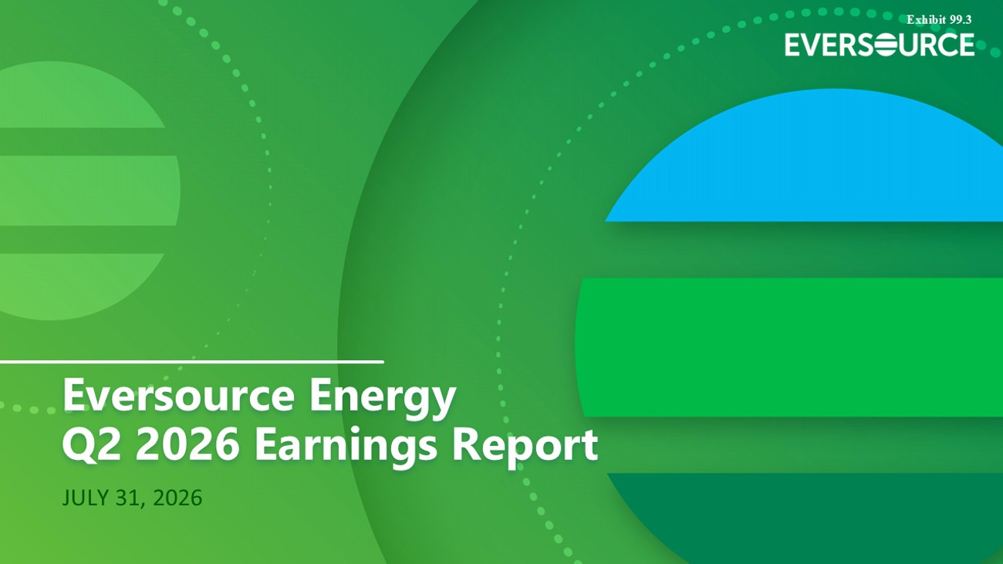
Q2 2026 EARNINGS REPORT July 31, 2026 JULY 31, 2026 Eversource Energy Q2 2026 Earnings Report Exhibit 99.3

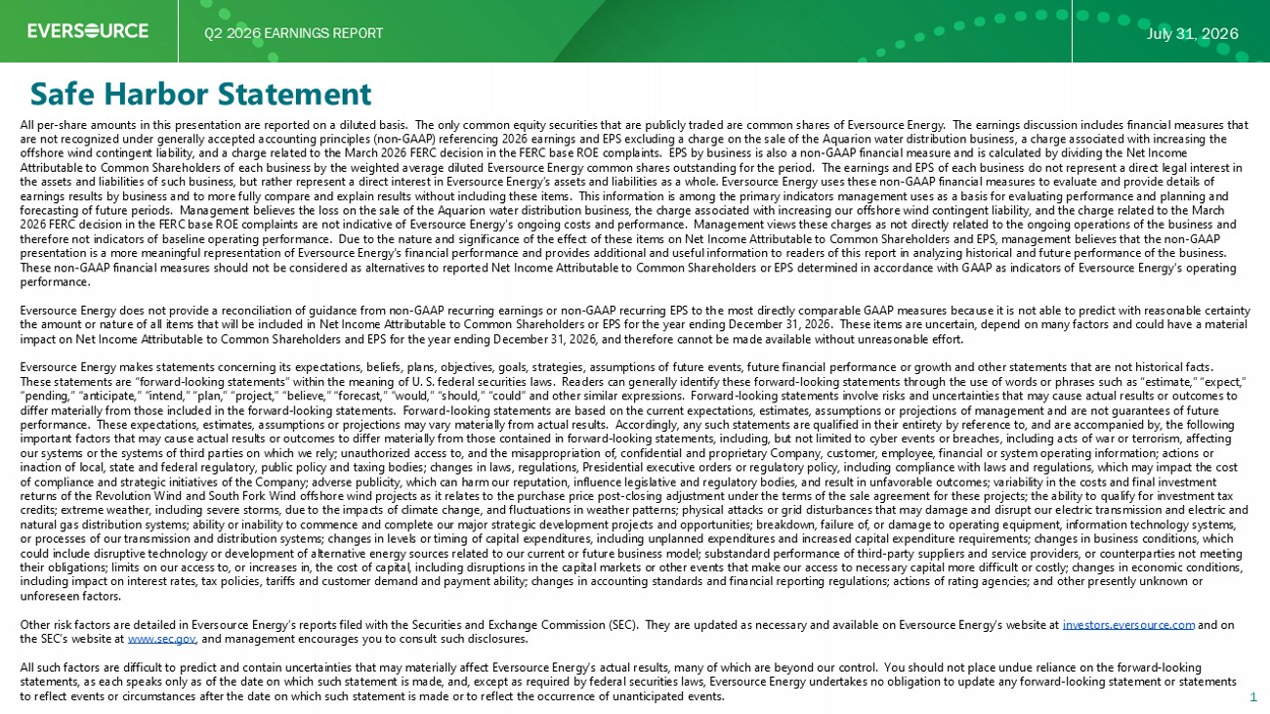
Q2 2026 EARNINGS REPORT July 31, 2026 Safe Harbor Statement 1 All per - share amounts in this presentation are reported on a diluted basis. The only common equity securities that are publicly traded are common shares of Eversource Energy. The earnings discussion includes financial measures that are not recognized under generally accepted accounting principles (non - GAAP) referencing 2026 earnings and EPS excluding a charg e on the sale of the Aquarion water distribution business, a charge associated with increasing the offshore wind contingent liability, and a charge related to the March 2026 FERC decision in the FERC base ROE complaints. EP S b y business is also a non - GAAP financial measure and is calculated by dividing the Net Income Attributable to Common Shareholders of each business by the weighted average diluted Eversource Energy common shares outstand ing for the period. The earnings and EPS of each business do not represent a direct legal interest in the assets and liabilities of such business, but rather represent a direct interest in Eversource Energy’s assets and liabili tie s as a whole. Eversource Energy uses these non - GAAP financial measures to evaluate and provide details of earnings results by business and to more fully compare and explain results without including these items. This information i s a mong the primary indicators management uses as a basis for evaluating performance and planning and forecasting of future periods. Management believes the loss on the sale of the Aquarion water distribution business, the cha rge associated with increasing our offshore wind contingent liability, and the charge related to the March 2026 FERC decision in the FERC base ROE complaints are not indicative of Eversource Energy's ongoing costs and performance. Man agement views these charges as not directly related to the ongoing operations of the business and therefore not indicators of baseline operating performance. Due to the nature and significance of the effect of these items on Net Income Attributable to Common Shareholders and EPS, management believes that the non - GAAP presentation is a more meaningful representation of Eversource Energy's financial performance and provides additional and use ful information to readers of this report in analyzing historical and future performance of the business. These non - GAAP financial measures should not be considered as alternatives to reported Net Income Attributable to Common Shareho lders or EPS determined in accordance with GAAP as indicators of Eversource Energy's operating performance. Eversource Energy does not provide a reconciliation of guidance from non - GAAP recurring earnings or non - GAAP recurring EPS to th e most directly comparable GAAP measures because it is not able to predict with reasonable certainty the amount or nature of all items that will be included in Net Income Attributable to Common Shareholders or EPS for the year en ding December 31, 2026. These items are uncertain, depend on many factors and could have a material impact on Net Income Attributable to Common Shareholders and EPS for the year ending December 31, 2026, and therefore cannot be made available without unreasonable effort. Eversource Energy makes statements concerning its expectations, beliefs, plans, objectives, goals, strategies, assumptions of fu ture events, future financial performance or growth and other statements that are not historical facts. These statements are “forward - looking statements” within the meaning of U. S. federal securities laws. Readers can generally id entify these forward - looking statements through the use of words or phrases such as “estimate,” “expect,” “pending,” “anticipate,” “intend,” “plan,” “project,” “believe,” “forecast,” “would,” “should,” “could” and other similar exp res sions. Forward - looking statements involve risks and uncertainties that may cause actual results or outcomes to differ materially from those included in the forward - looking statements. Forward - looking statements are based on the current ex pectations, estimates, assumptions or projections of management and are not guarantees of future performance. These expectations, estimates, assumptions or projections may vary materially from actual results. Accordingly , a ny such statements are qualified in their entirety by reference to, and are accompanied by, the following important factors that may cause actual results or outcomes to differ materially from those contained in forward - looking stateme nts, including, but not limited to cyber events or breaches, including acts of war or terrorism, affecting our systems or the systems of third parties on which we rely; unauthorized access to, and the misappropriation of, confidenti al and proprietary Company, customer, employee, financial or system operating information; actions or inaction of local, state and federal regulatory, public policy and taxing bodies; changes in laws, regulations, Presidential exe cutive orders or regulatory policy, including compliance with laws and regulations, which may impact the cost of compliance and strategic initiatives of the Company; adverse publicity, which can harm our reputation, influence legislati ve and regulatory bodies, and result in unfavorable outcomes; variability in the costs and final investment returns of the Revolution Wind and South Fork Wind offshore wind projects as it relates to the purchase price post - closing adjus tment under the terms of the sale agreement for these projects; the ability to qualify for investment tax credits; extreme weather, including severe storms, due to the impacts of climate change, and fluctuations in weather patterns ; p hysical attacks or grid disturbances that may damage and disrupt our electric transmission and electric and natural gas distribution systems; ability or inability to commence and complete our major strategic development projects and opp ortunities; breakdown, failure of, or damage to operating equipment, information technology systems, or processes of our transmission and distribution systems; changes in levels or timing of capital expenditures, including unp lan ned expenditures and increased capital expenditure requirements; changes in business conditions, which could include disruptive technology or development of alternative energy sources related to our current or future business mo del ; substandard performance of third - party suppliers and service providers, or counterparties not meeting their obligations; limits on our access to, or increases in, the cost of capital, including disruptions in the capital market s o r other events that make our access to necessary capital more difficult or costly; changes in economic conditions, including impact on interest rates, tax policies, tariffs and customer demand and payment ability; changes in accounting stan dar ds and financial reporting regulations; actions of rating agencies; and other presently unknown or unforeseen factors. Other risk factors are detailed in Eversource Energy’s reports filed with the Securities and Exchange Commission (SEC). They ar e updated as necessary and available on Eversource Energy’s website at investors.eversource.com and on the SEC’s website at www.sec.gov , and management encourages you to consult such disclosures. All such factors are difficult to predict and contain uncertainties that may materially affect Eversource Energy’s actual res ult s, many of which are beyond our control. You should not place undue reliance on the forward - looking statements, as each speaks only as of the date on which such statement is made, and, except as required by federal securities la ws, Eversource Energy undertakes no obligation to update any forward - looking statement or statements to reflect events or circumstances after the date on which such statement is made or to reflect the occurrence of unanticipat ed events.

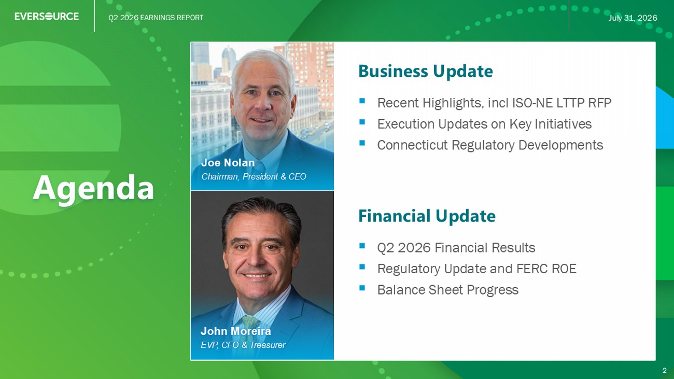
Q2 2026 EARNINGS REPORT July 31, 2026 Agenda Business Update ▪ Recent Highlights, incl ISO - NE LTTP RFP ▪ Execution Updates on Key Initiatives ▪ Connecticut Regulatory Developments 2 Joe Nolan Chairman, President & CEO Financial Update ▪ Q2 2026 Financial Results ▪ Regulatory Update and FERC ROE ▪ Balance Sheet Progress John Moreira EVP, CFO & Treasurer


Q2 2026 EARNINGS REPORT July 31, 2026 Q2 2026 EARNINGS REPORT 3 CHAIRMAN, PRESIDENT & CHIEF EXECUTIVE OFFICER Joe Nolan Business Update

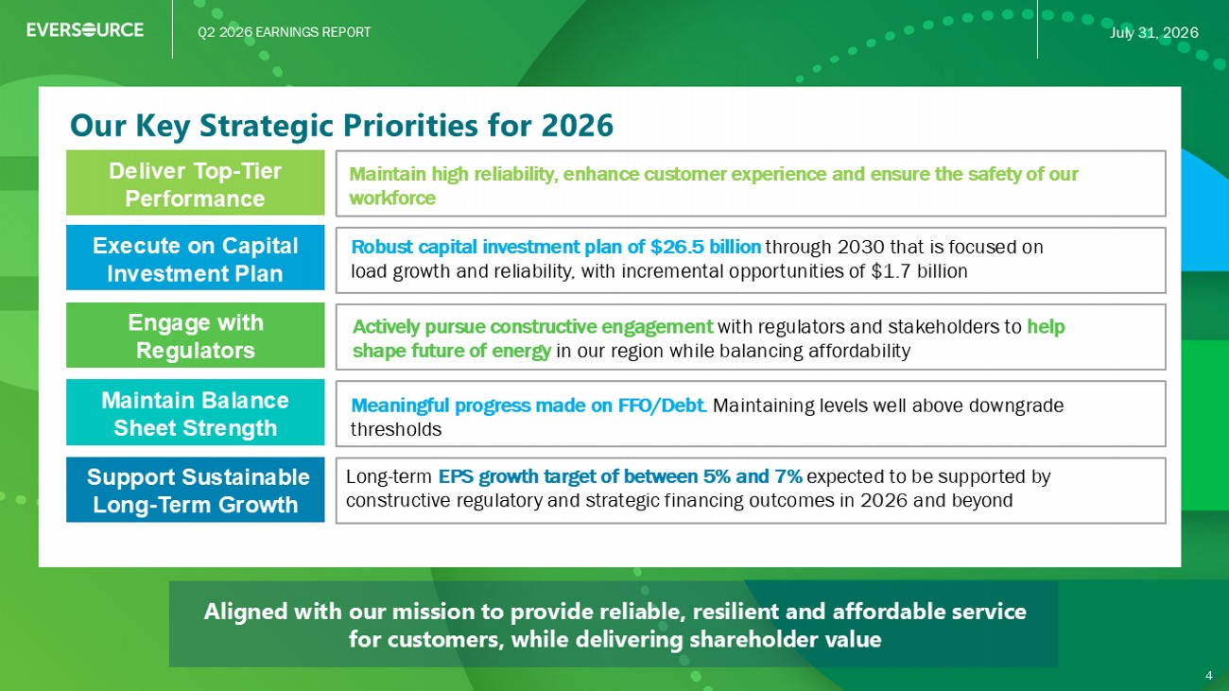
Q2 2026 EARNINGS REPORT July 31, 2026 Aligned with our mission to provide reliable, resilient and affordable service for customers, while delivering shareholder value Our Key Strategic Priorities for 2026 Long - term EPS growth target of between 5% and 7% expected to be supported by constructive regulatory and strategic financing outcomes in 2026 and beyond Execute on Capital Investment Plan Maintain Balance Sheet Strength Deliver Top - Tier Performance Robust capital investment plan of $26.5 billion through 2030 that is focused on load growth and reliability, with incremental opportunities of $1.7 billion Meaningful progress made on FFO/Debt. Maintaining levels well above downgrade thresholds Maintain high reliability, enhance customer experience and ensure the safety of our workforce Engage with Regulators Actively pursue constructive engagement with regulators and stakeholders to help shape future of energy in our region while balancing affordability Support Sustainable Long - Term Growth 4

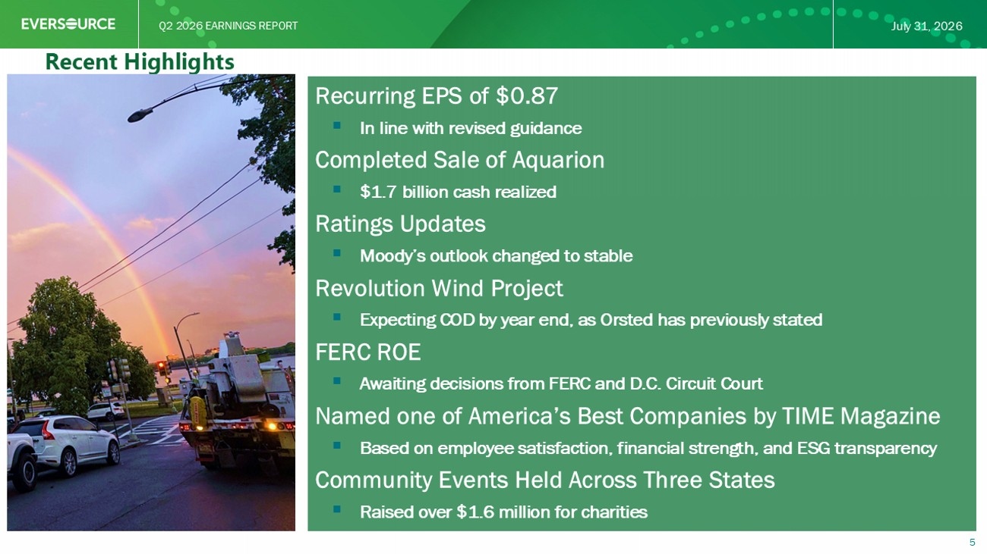
Q2 2026 EARNINGS REPORT July 31, 2026 5 Recent Highlights Recurring EPS of $0.87 ▪ In line with revised guidance Completed Sale of Aquarion ▪ $1.7 billion cash realized Ratings Updates ▪ Moody’s outlook changed to stable Revolution Wind Project ▪ Expecting COD by year end, as Orsted has previously stated FERC ROE ▪ Awaiting decisions from FERC and D.C. Circuit Court Named one of America’s Best Companies by TIME Magazine ▪ Based on employee satisfaction, financial strength, and ESG transparency Community Events Held Across Three States ▪ Raised over $1.6 million for charities

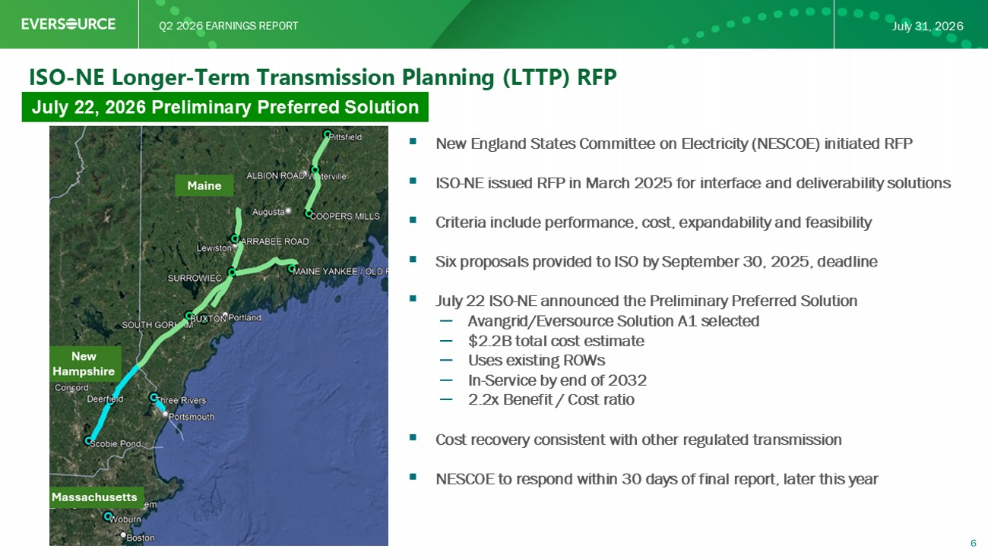
Q2 2026 EARNINGS REPORT July 31, 2026 6 ISO - NE Longer - Term Transmission Planning (LTTP) RFP July 22, 2026 Preliminary Preferred Solution ▪ New England States Committee on Electricity (NESCOE) initiated RFP ▪ ISO - NE issued RFP in March 2025 for interface and deliverability solutions ▪ Criteria include performance, cost, expandability and feasibility ▪ Six proposals provided to ISO by September 30, 2025, deadline ▪ July 22 ISO - NE announced the Preliminary Preferred Solution – Avangrid/Eversource Solution A1 selected – $2.2B total cost estimate – Uses existing ROWs – In - Service by end of 2032 – 2.2x Benefit / Cost ratio ▪ Cost recovery consistent with other regulated transmission ▪ NESCOE to respond within 30 days of final report, later this year

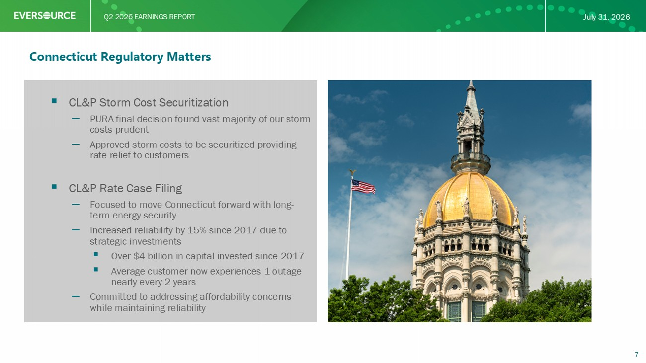
Q2 2026 EARNINGS REPORT July 31, 2026 Connecticut Regulatory Matters ▪ CL&P Storm Cost Securitization – PURA final decision found vast majority of our storm costs prudent – Approved storm costs to be securitized providing rate relief to customers ▪ CL&P Rate Case Filing – Focused to move Connecticut forward with long - term energy security – Increased reliability by 15% since 2017 due to strategic investments ▪ Over $4 billion in capital invested since 2017 ▪ Average customer now experiences 1 outage nearly every 2 years – Committed to addressing affordability concerns while maintaining reliability 7

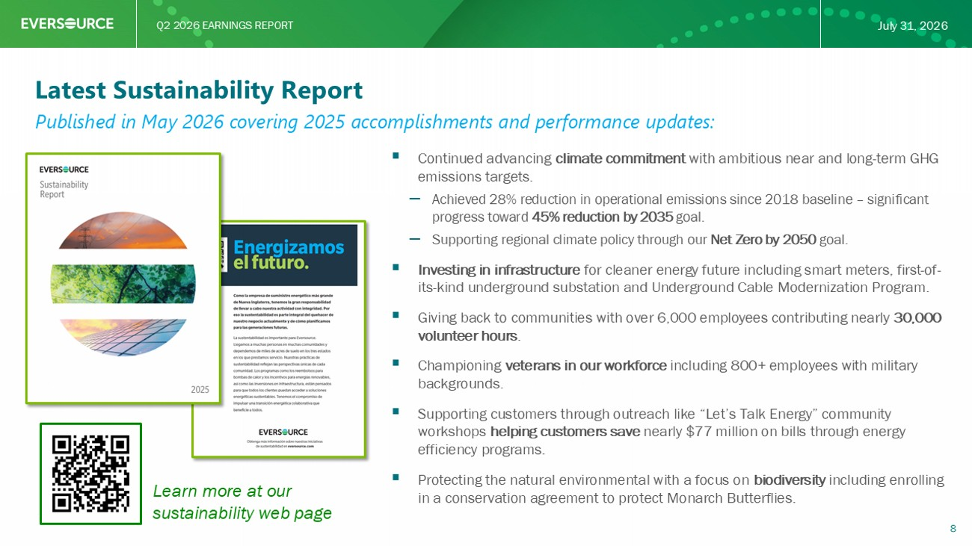
Q2 2026 EARNINGS REPORT July 31, 2026 Latest Sustainability Report ▪ Continued advancing climate commitment with ambitious near and long - term GHG emissions targets. – Achieved 28% reduction in operational emissions since 2018 baseline – significant progress toward 45% reduction by 2035 goal. – Supporting regional climate policy through our Net Zero by 2050 goal. ▪ Investing in infrastructure for cleaner energy future including smart meters, first - of - its - kind underground substation and Underground Cable Modernization Program. ▪ Giving back to communities with over 6,000 employees contributing nearly 30,000 volunteer hours . ▪ Championing veterans in our workforce including 800+ employees with military backgrounds. ▪ Supporting customers through outreach like “Let’s Talk Energy” community workshops helping customers save nearly $77 million on bills through energy efficiency programs. ▪ Protecting the natural environmental with a focus on biodiversity including enrolling in a conservation agreement to protect Monarch Butterflies. 8 Learn more at our sustainability web page Published in May 2026 covering 2025 accomplishments and performance updates:


Q2 2026 EARNINGS REPORT July 31, 2026 Q2 2026 EARNINGS REPORT 9 EXECUTIVE VICE PRESIDENT, CHIEF FINANCIAL OFFICER & TREASURER John Moreira Financial Update

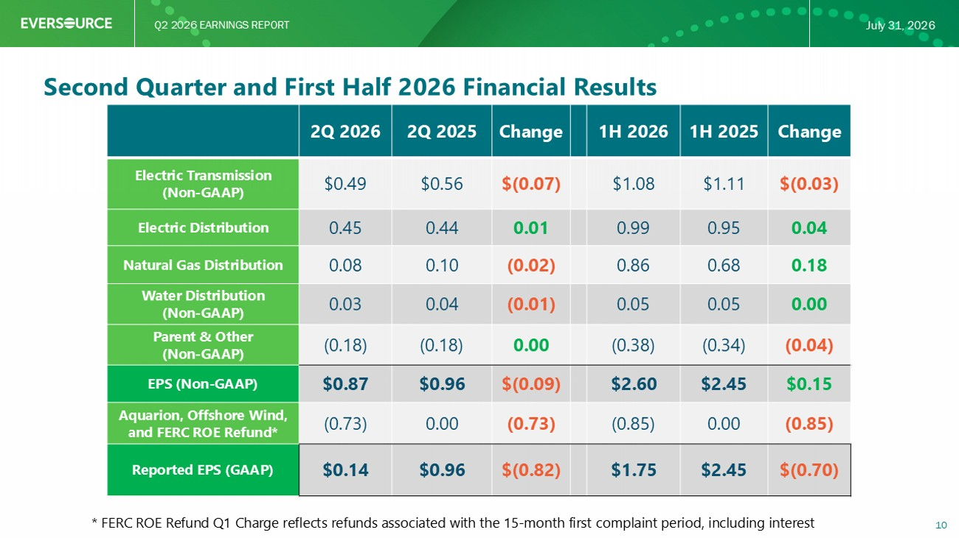
Q2 2026 EARNINGS REPORT July 31, 2026 Second Quarter and First Half 2026 Financial Results 10 Change 1H 2025 1H 2026 Change 2Q 2025 2Q 2026 $(0.03) $1.11 $1.08 $(0.07) $0.56 $0.49 Electric Transmission (Non - GAAP) 0.04 0.95 0.99 0.01 0.44 0.45 Electric Distribution 0.18 0.68 0.86 (0.02) 0.10 0.08 Natural Gas Distribution 0.00 0.05 0.05 (0.01) 0.04 0.03 Water Distribution (Non - GAAP) (0.04) (0.34) (0.38) 0.00 (0.18) (0.18) Parent & Other (Non - GAAP) $0.15 $2.45 $2.60 $(0.09) $0.96 $0.87 EPS (Non - GAAP) (0.85) 0.00 (0.85) (0.73) 0.00 (0.73) Aquarion, Offshore Wind, and FERC ROE Refund* $(0.70) $2.45 $1.75 $(0.82) $0.96 $0.14 Reported EPS (GAAP) * FERC ROE Refund Q1 Charge reflects refunds associated with the 15 - month first complaint period, including interest

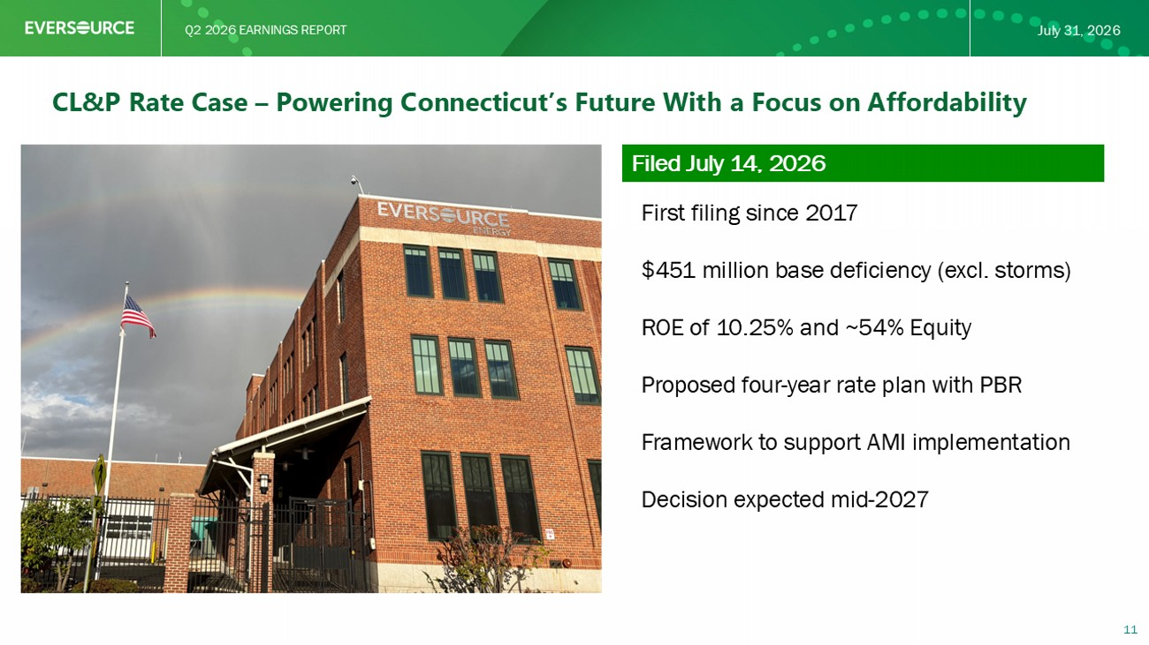
Q2 2026 EARNINGS REPORT July 31, 2026 CL&P Rate Case – Powering Connecticut’s Future With a Focus on Affordability 11 Filed July 14, 2026 First filing since 2017 $451 million base deficiency (excl. storms) ROE of 10.25% and ~54% Equity Proposed four - year rate plan with PBR Framework to support AMI implementation Decision expected mid - 2027

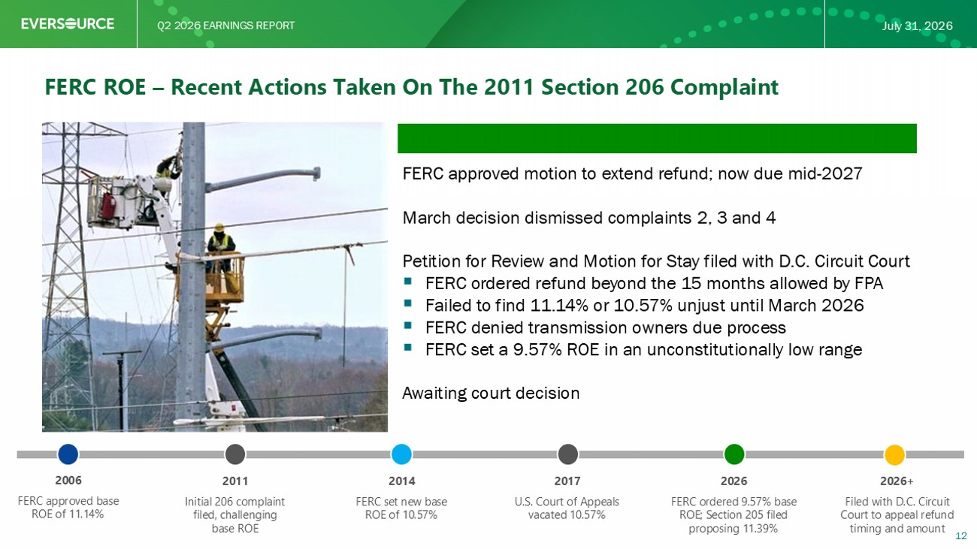
Q2 2026 EARNINGS REPORT July 31, 2026 FERC ROE – Recent Actions Taken On The 2011 Section 206 Complaint 12 FERC approved motion to extend refund; now due mid - 2027 March decision dismissed complaints 2, 3 and 4 Petition for Review and Motion for Stay filed with D.C. Circuit Court ▪ FERC ordered refund beyond the 15 months allowed by FPA ▪ Failed to find 11.14% or 10.57% unjust until March 2026 ▪ FERC denied transmission owners due process ▪ FERC set a 9.57% ROE in an unconstitutionally low range Awaiting court decision 2006 FERC approved base ROE of 11.14% 2011 Initial 206 complaint filed, challenging base ROE 2014 FERC set new base ROE of 10.57% 2017 U.S. Court of Appeals vacated 10.57% 2026 FERC ordered 9.57% base ROE; Section 205 filed proposing 11.39% 2026+ Filed with D.C. Circuit Court to appeal refund timing and amount

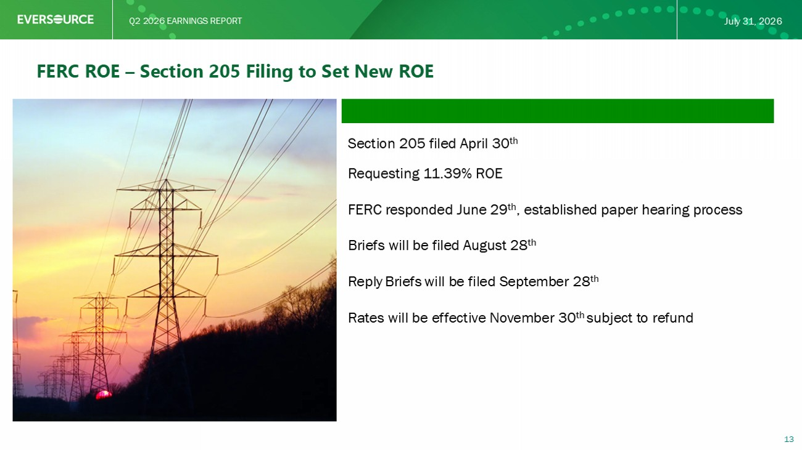
Q2 2026 EARNINGS REPORT July 31, 2026 FERC ROE – Section 205 Filing to Set New ROE Section 205 filed April 30 th Requesting 11.39% ROE FERC responded June 29 th , established paper hearing process Briefs will be filed August 28 th Reply Briefs will be filed September 28 th Rates will be effective November 30 th subject to refund 13

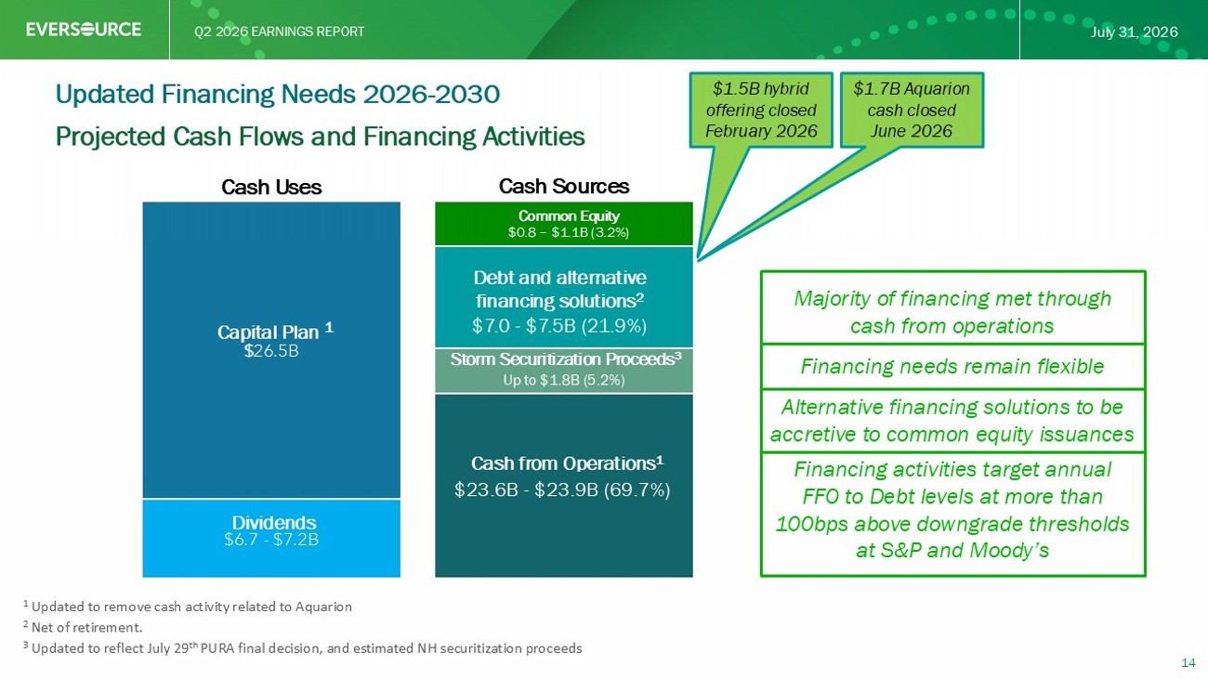
Q2 2026 EARNINGS REPORT July 31, 2026 $6.7 - $7.2B $ 26.5B $24.2 - $24.7B (68.0%) $8.5 - $9.0B (27.0%) $0.8 - $1.1B (2.0%) Projected Cash Flows and Financing Activities 14 Updated Financing Needs 2026 - 2030 Cash Uses Cash Sources Common Equity Debt and alternative financing solutions 2 Cash from Operations 1 Dividends Capital Plan 1 1 Updated to remove cash activity related to Aquarion 2 Net of retirement. 3 Updated to reflect July 29 th PURA final decision, and estimated NH securitization proceeds Majority of financing met through cash from operations Financing needs remain flexible Alternative financing solutions to be accretive to common equity issuances Financing activities target annual FFO to Debt levels at more than 100bps above downgrade thresholds at S&P and Moody’s Storm Securitization Proceeds 3 [With equity content of $1.3 - $2.5B] $1.8B (5.2%) $1.5B hybrid offering closed February 2026 $1.7B Aquarion cash closed June 2026 Debt and alternative financing solutions 2 $7.0 - $7.5B (21.9%) Common Equity $0.8 – $1.1B (3.2%) $23.6B - $23.9B (69.7%)

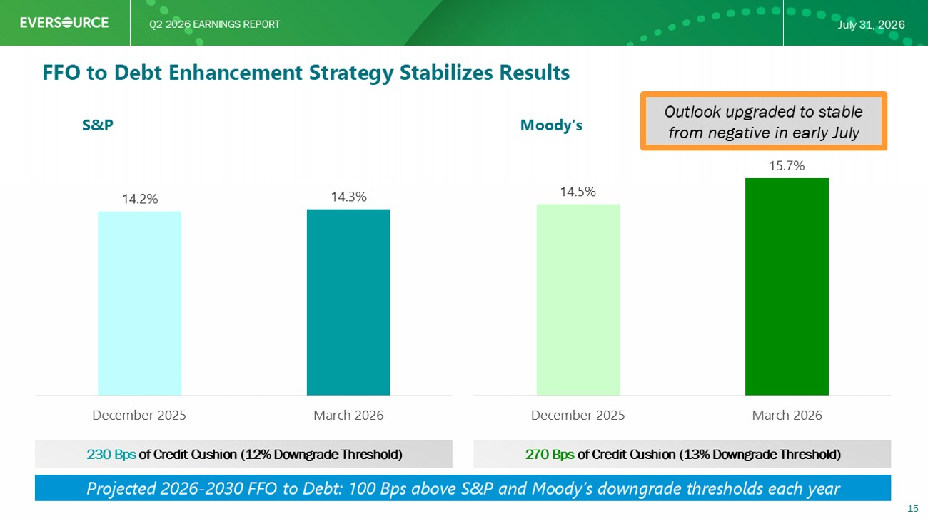
Q2 2026 EARNINGS REPORT July 31, 2026 FFO to Debt Enhancement Strategy Stabilizes Results S&P Moody’s 14.2% 14.3% December 2025 March 2026 14.5% 15.7% December 2025 March 2026 230 Bps of Credit Cushion (12% Downgrade Threshold) 270 Bps of Credit Cushion (13% Downgrade Threshold) 15 Projected 2026 - 2030 FFO to Debt: 100 Bps above S&P and Moody’s downgrade thresholds each year Outlook upgraded to stable from negative in early July

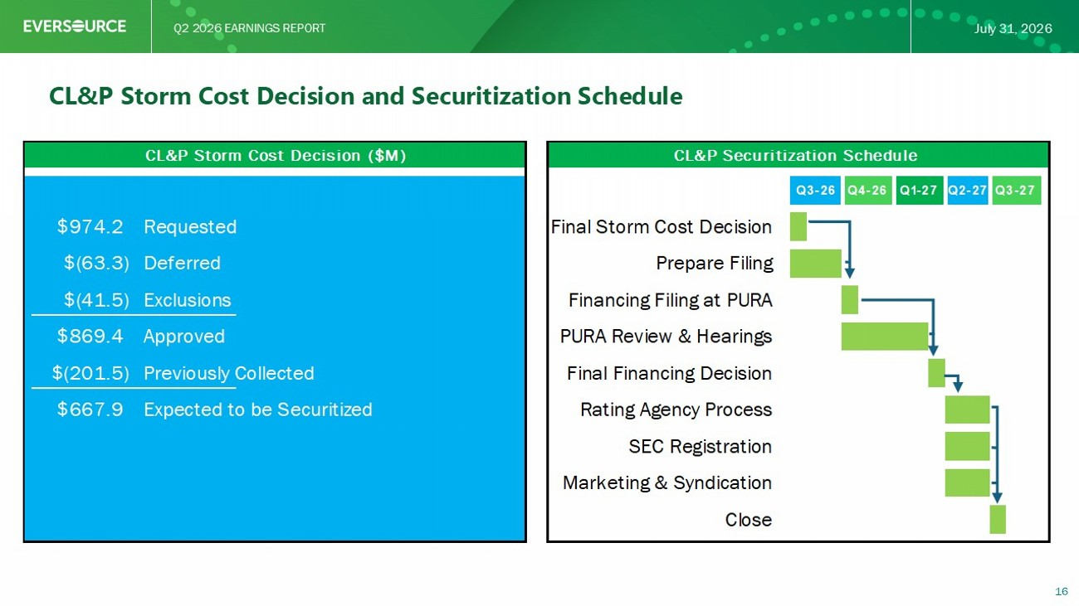
Q2 2026 EARNINGS REPORT July 31, 2026 Projected Connecticut Securitization Process 16 Q2 2027 Final Storm Cost Decision 974.2$ Requested Q1 2027Q3 2026Q4 2026 Q3 2027 $ In Millions Prepare Filing (63.3)$ Deferred Financing Filing at PURA (41.5)$ Exclusions PURA Review & Hearings 869.4$ Approved Final Financing Decision (201.5)$ In rates Rating Agency Process 667.9$ Securitization SEC Registration Marketing & Syndication Close

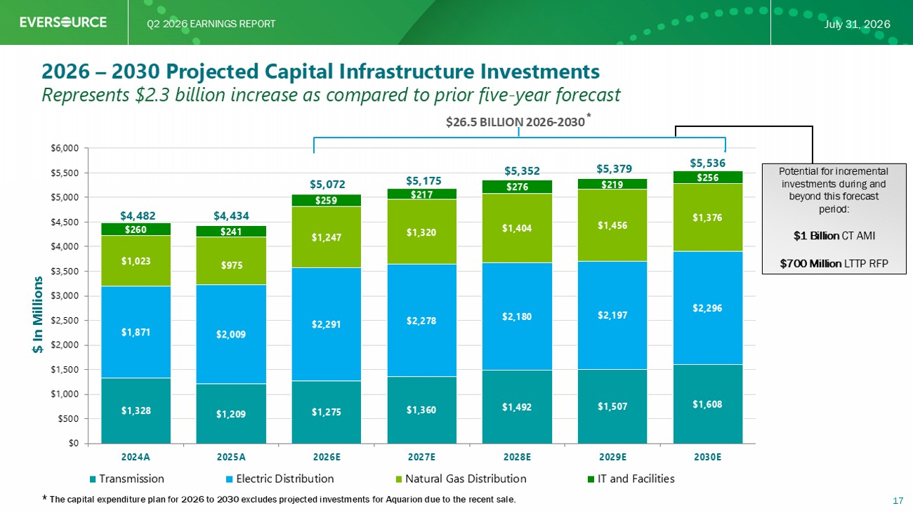
Q2 2026 EARNINGS REPORT July 31, 2026 $1,328 $1,209 $1,275 $1,360 $1,492 $1,507 $1,608 $1,871 $2,009 $2,291 $2,278 $2,180 $2,197 $2,296 $1,023 $975 $1,247 $1,320 $1,404 $1,456 $1,376 $260 $241 $259 $217 $276 $219 $256 $4,482 $4,434 $5,072 $5,175 $5,352 $5,379 $5,536 $0 $500 $1,000 $1,500 $2,000 $2,500 $3,000 $3,500 $4,000 $4,500 $5,000 $5,500 $6,000 2024A 2025A 2026E 2027E 2028E 2029E 2030E Transmission Electric Distribution Natural Gas Distribution IT and Facilities $ In Millions $26.5 BILLION 2026 - 2030 * 2026 – 2030 Projected Capital Infrastructure Investments 17 Represents $2.3 billion increase as compared to prior five - year forecast Potential for incremental investments during and beyond this forecast period: $1 Billion CT AMI $700 Million LTTP RFP * The capital expenditure plan for 2026 to 2030 excludes projected investments for Aquarion due to the recent sale.

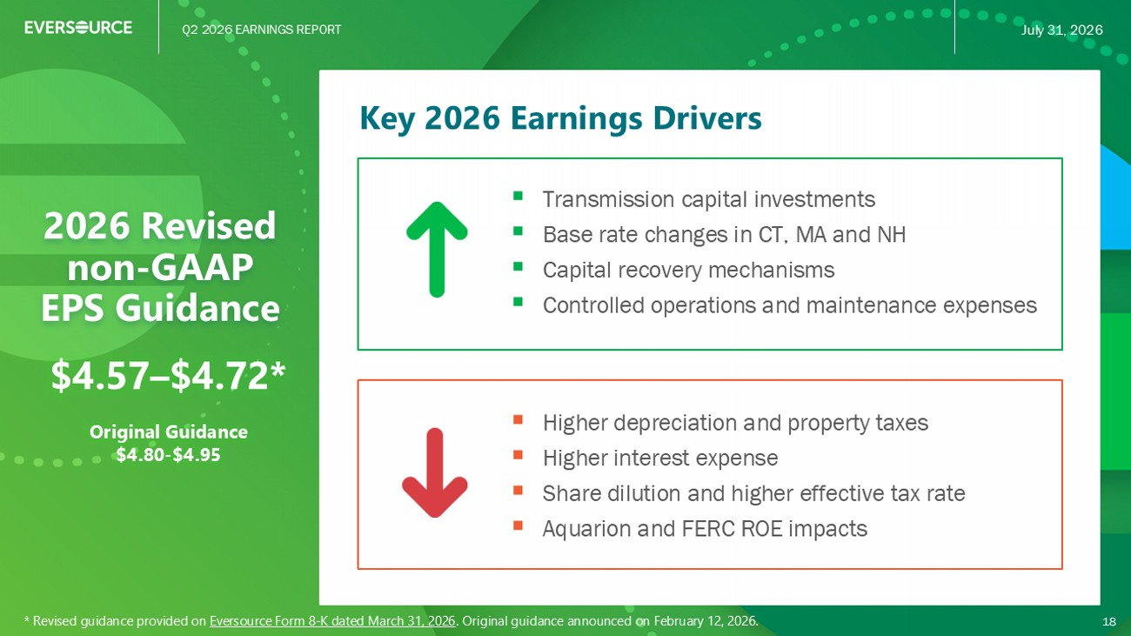
Q2 2026 EARNINGS REPORT July 31, 2026 Key 2026 Earnings Drivers 2026 Revised non - GAAP EPS Guidance ▪ Transmission capital investments ▪ Base rate changes in CT, MA and NH ▪ Capital recovery mechanisms ▪ Controlled operations and maintenance expenses 18 ▪ Higher depreciation and property taxes ▪ Higher interest expense ▪ Share dilution and higher effective tax rate ▪ Aquarion and FERC ROE impacts $4.57 – $4.72* Original Guidance $4.80 - $4.95 * Revised guidance provided on Eversource Form 8 - K dated March 31, 2026 . Original guidance announced on February 12, 2026.

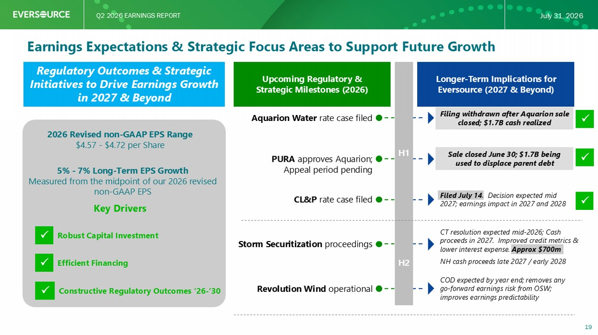
Q2 2026 EARNINGS REPORT July 31, 2026 Earnings Expectations & Strategic Focus Areas to Support Future Growth Upcoming Regulatory & Strategic Milestones (2026) Regulatory Outcomes & Strategic Initiatives to Drive Earnings Growth in 2027 & Beyond 2026 Revised non - GAAP EPS Range $4. 57 - $4.72 per Share 5% - 7% Long - Term EPS Growth Measured from the midpoint of our 2026 revised non - GAAP EPS Key Drivers Robust Capital Investment Efficient Financing Constructive Regulatory Outcomes ’26 - ’30 Longer - Term Implications for Eversource (2027 & Beyond) Aquarion Water rate case filed CL&P rate case filed PURA approves Aquarion; Appeal period pending Storm Securitization proceedings Revolution Wind operational Filing withdrawn after Aquarion sale closed; $1.7B cash realized Sale closed June 30; $1.7B being used to displace parent debt Filed July 14 . Decision expected mid 2027; earnings impact in 2027 and 2028 CT resolution expected mid - 2026; Cash proceeds in 2027. Improved credit metrics & lower interest expense. Approx $700m NH cash proceeds late 2027 / early 2028 COD expected by year end; removes any go - forward earnings risk from OSW; improves earnings predictability 19 H1 H2


Q2 2026 EARNINGS REPORT July 31, 2026 Q & A 20


Q2 2026 EARNINGS REPORT July 31, 2026 Appendix 21

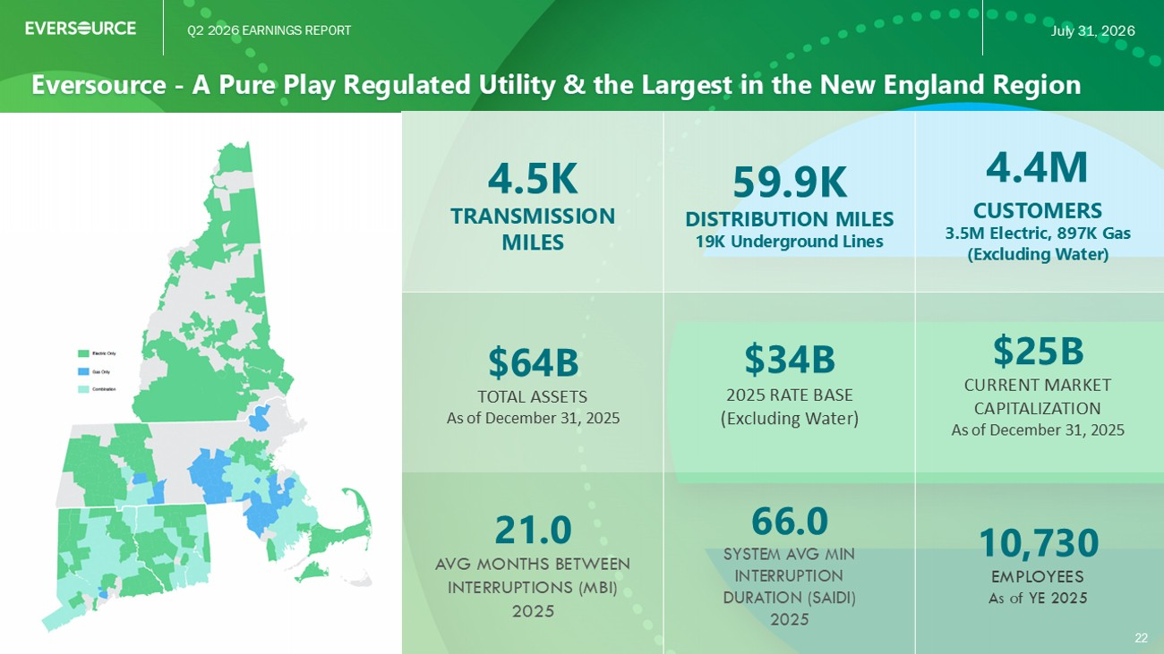
Q2 2026 EARNINGS REPORT July 31, 2026 Eversource - A Pure Play Regulated Utility & the Largest in the New England Region 22 4.4M CUSTOMERS 3.5M Electric, 897K Gas (Excluding Water) 59.9K DISTRIBUTION MILES 19K Underground Lines 4.5K TRANSMISSION MILES $25B CURRENT MARKET CAPITALIZATION As of December 31, 2025 $34B 2025 RATE BASE (Excluding Water) $64B TOTAL ASSETS As of December 31, 2025 10,730 EMPLOYEES As of YE 2025 66.0 SYSTEM AVG MIN INTERRUPTION DURATION (SAIDI) 2025 21.0 AVG MONTHS BETWEEN INTERRUPTIONS (MBI) 2025

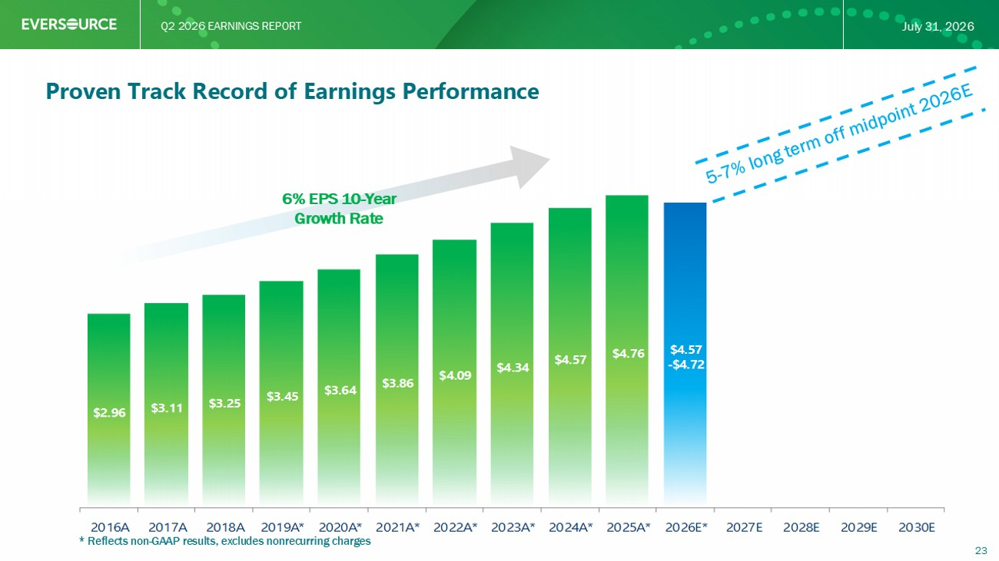
Q2 2026 EARNINGS REPORT July 31, 2026 $2.96 $3.11 $3.25 $3.45 $3.64 $3.86 $4.09 $4.34 $4.57 $4.76 $4.57 - $4.72 2016A 2017A 2018A 2019A* 2020A* 2021A* 2022A* 2023A* 2024A* 2025A* 2026E* 2027E 2028E 2029E 2030E * Reflects non - GAAP results, excludes nonrecurring charges 23 Proven Track Record of Earnings Performance 6% EPS 10 - Year Growth Rate

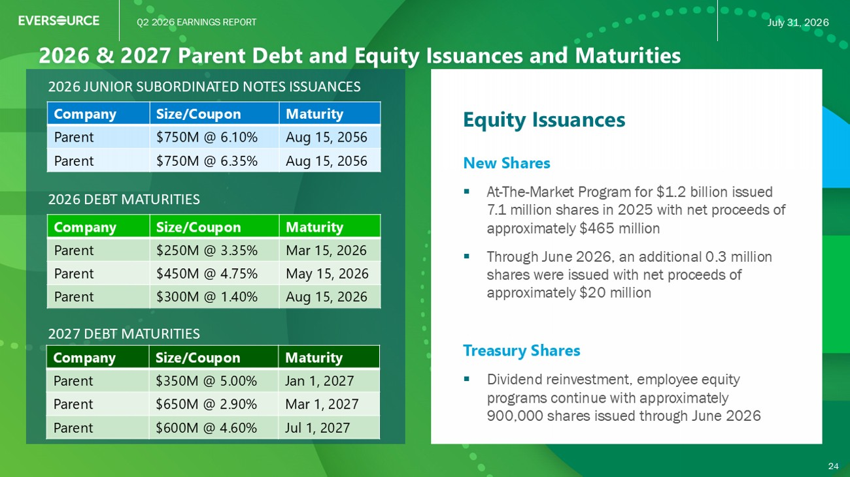
Q2 2026 EARNINGS REPORT July 31, 2026 2026 & 2027 Parent Debt and Equity Issuances and Maturities 24 Equity Issuances New Shares ▪ At - The - Market Program for $1.2 billion issued 7.1 million shares in 2025 with net proceeds of approximately $ 465 million ▪ Through June 2026, an additional 0.3 million shares were issued with net proceeds of approximately $20 million Treasury Shares ▪ Dividend reinvestment, employee equity programs continue with approximately 900,000 shares issued through June 2026 2026 DEBT MATURITIES Maturity Size/Coupon Company Mar 15, 2026 $250M @ 3.35% Parent May 15, 2026 $450M @ 4.75% Parent Aug 15, 2026 $300M @ 1.40% Parent 24 2026 JUNIOR SUBORDINATED NOTES ISSUANCES Maturity Size/Coupon Company Aug 15, 2056 $750M @ 6.10% Parent Aug 15, 2056 $750M @ 6.35% Parent 2027 DEBT MATURITIES Maturity Size/Coupon Company Jan 1, 2027 $350M @ 5.00% Parent Mar 1, 2027 $650M @ 2.90% Parent Jul 1, 2027 $600M @ 4.60% Parent

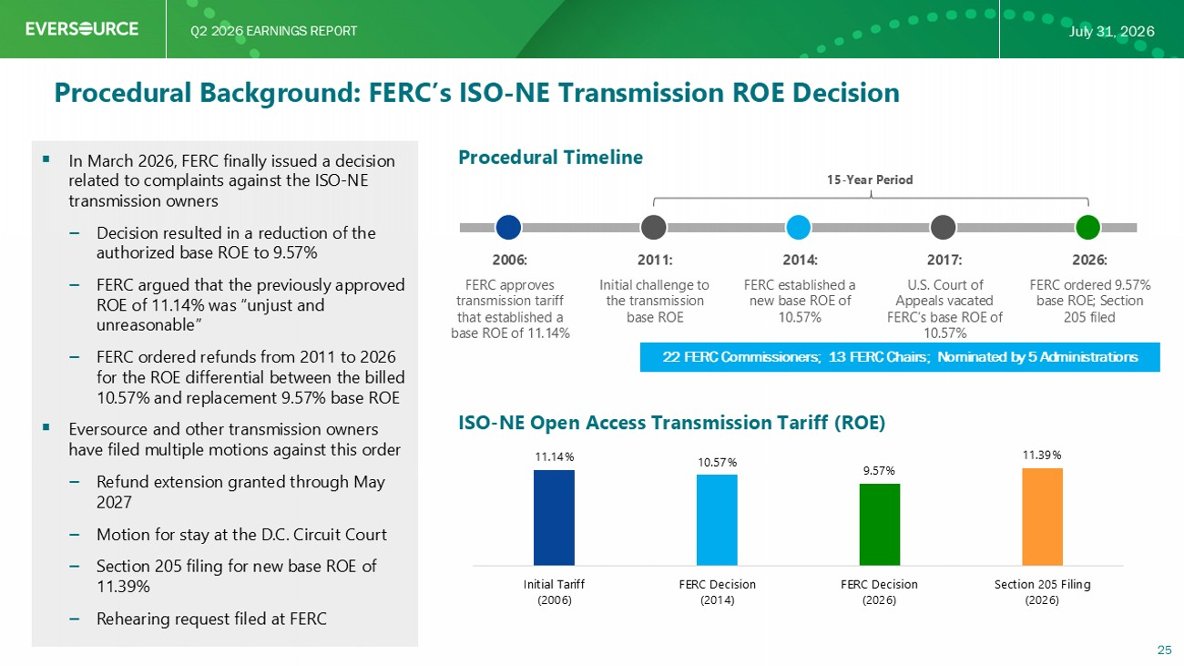
Q2 2026 EARNINGS REPORT July 31, 2026 Procedural Background: FERC’s ISO - NE Transmission ROE Decision Procedural Timeline ▪ In March 2026, FERC finally issued a decision related to complaints against the ISO - NE transmission owners ‒ Decision resulted in a reduction of the authorized base ROE to 9.57% ‒ FERC argued that the previously approved ROE of 11.14% was “unjust and unreasonable” ‒ FERC ordered refunds from 2011 to 2026 for the ROE differential between the billed 10.57% and replacement 9.57% base ROE ▪ Eversource and other transmission owners have filed multiple motions against this order ‒ Re fund extension granted through May 2027 ‒ Motion for stay at the D.C. Circuit Court ‒ Section 205 filing for new base ROE of 11.39% ‒ Rehearing request filed at FERC 25 ISO - NE Open Access Transmission Tariff (ROE) 11.14% 10.57% 9.57% 11.39% Initial Tariff (2006) FERC Decision (2014) FERC Decision (2026) Section 205 Filing (2026) 2006: FERC approves transmission tariff that established a base ROE of 11.14% 2011: Initial challenge to the transmission base ROE 2014: FERC established a new base ROE of 10.57% 2017: U.S. Court of Appeals vacated FERC’s base ROE of 10.57% 2026: FERC ordered 9.57% base ROE; Section 205 filed 15 - Year Period 22 FERC Commissioners; 13 FERC Chairs; Nominated by 5 Administrations

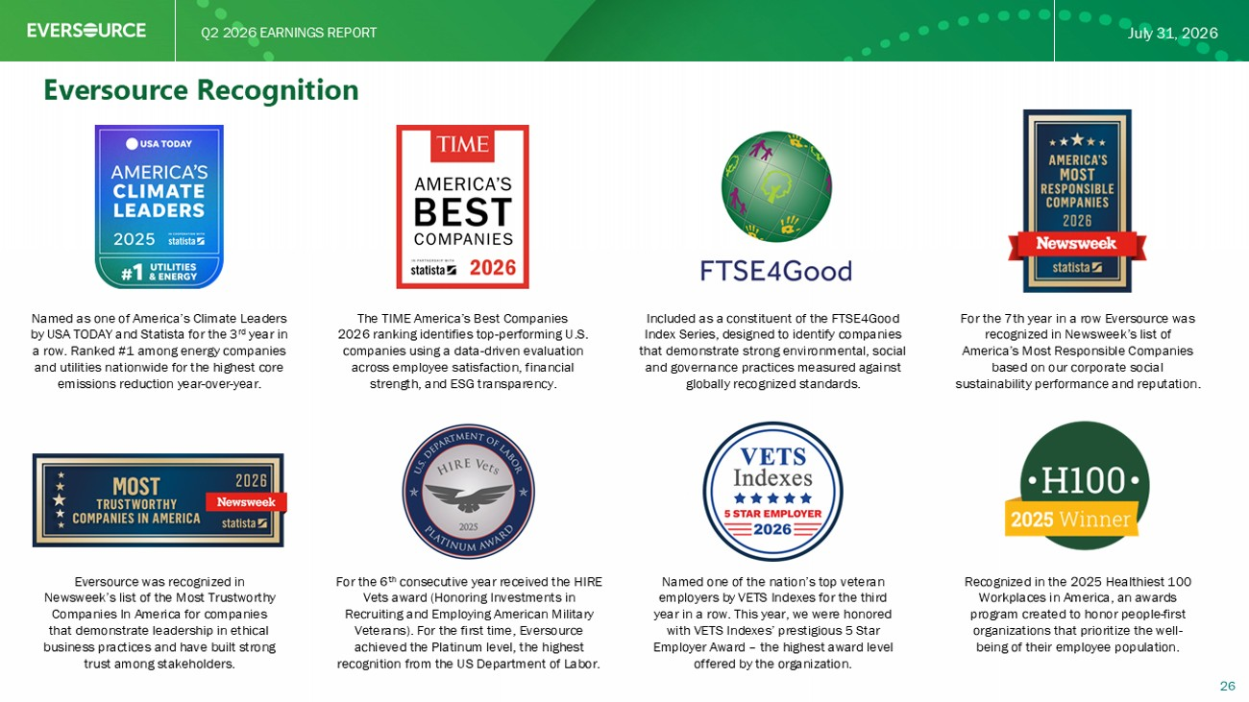
Q2 2026 EARNINGS REPORT July 31, 2026 For the 6 th consecutive year received the HIRE Vets award (Honoring Investments in Recruiting and Employing American Military Veterans). For the first time, Eversource achieved the Platinum level, the highest recognition from the US Department of Labor. Named as one of America’s Climate Leaders by USA TODAY and Statista for the 3 rd year in a row. Ranked #1 among energy companies and utilities nationwide for the highest core emissions reduction year - over - year. For the 7th year in a row Eversource was recognized in Newsweek’s list of America’s Most Responsible Companies based on our corporate social sustainability performance and reputation. Eversource was recognized in Newsweek’s list of the Most Trustworthy Companies In America for companies that demonstrate leadership in ethical business practices and have built strong trust among stakeholders. Included as a constituent of the FTSE4Good Index Series, designed to identify companies that demonstrate strong environmental, social and governance practices measured against globally recognized standards. Recognized in the 2025 Healthiest 100 Workplaces in America, an awards program created to honor people - first organizations that prioritize the well - being of their employee population. 26 Eversource Recognition Named one of the nation’s top veteran employers by VETS Indexes for the third year in a row. This year, we were honored with VETS Indexes’ prestigious 5 Star Employer Award – the highest award level offered by the organization. The TIME America’s Best Companies 2026 ranking identifies top - performing U.S. companies using a data - driven evaluation across employee satisfaction, financial strength, and ESG transparency.

