UNITED STATES
SECURITIES AND EXCHANGE COMMISSION
Washington, D.C. 20549

FORM 8-K

CURRENT REPORT
Pursuant to Section 13 or 15(d) of the Securities Exchange Act of 1934
Date of Report (Date of earliest event reported): May 6, 2026

Commission  File Number | Registrant; State of Incorporation  Address; and Telephone Number | I.R.S. Employer  Identification No.
1-5324 | EVERSOURCE ENERGY  (a Massachusetts voluntary association)  300 Cadwell Drive  Springfield, Massachusetts 01104  Telephone: (800) 286-5000 | 04-2147929
0-00404 | THE CONNECTICUT LIGHT AND POWER COMPANY  (a Connecticut corporation)  107 Selden Street  Berlin, Connecticut 06037-1616  Telephone: (800) 286-5000 | 06-0303850
1-02301 | NSTAR ELECTRIC COMPANY  (a Massachusetts corporation)  800 Boylston Street  Boston, Massachusetts 02199  Telephone: (800) 286-5000 | 04-1278810
1-6392 | PUBLIC SERVICE COMPANY OF NEW HAMPSHIRE  (a New Hampshire corporation)  Energy Park  780 North Commercial Street  Manchester, New Hampshire 03101-1134  Telephone: (800) 286-5000 | 02-0181050

Not Applicable
(Former name or former address, if changed since last report)

Check the appropriate box below if the Form 8-K filing is intended to simultaneously satisfy the filing obligation of the registrant under any of the following provisions (see General Instruction A.2. below):

 | ☐ | Written communications pursuant to Rule 425 under the Securities Act (17 CFR 230.425)

 | ☐ | Soliciting material pursuant to Rule 14a-12 under the Exchange Act (17 CFR 240.14a-12)

 | ☐ | Pre-commencement communications pursuant to Rule 14d-2(b) under the Exchange Act (17 CFR 240.14d-2(b))

 | ☐ | Pre-commencement communications pursuant to Rule 13e-4(c) under the Exchange Act (17 CFR 240.13e-4(c))

Securities registered pursuant to Section 12(b) of the Act:

Registrant | Title of each class | Trading  Symbol(s) | Name of each exchange on  which registered
Eversource Energy | Common Shares, $5.00 par value per share | ES | New York Stock Exchange

Indicate by check mark whether the registrant is an emerging growth company as defined in Rule 405 of the Securities Act of 1933 (§230.405 of this chapter) or Rule 12b-2 of the Securities Exchange Act of 1934 (§240.12b-2 of this chapter).

Emerging growth
company
Eversource Energy | ☐
The Connecticut Light and Power Company | ☐
NSTAR Electric Company | ☐
Public Service Company of New Hampshire | ☐

If an emerging growth company, indicate by check mark if the registrant has elected not to use the extended transition period for complying with any new or revised financial accounting standards provided pursuant to Section 13(a) of the Exchange Act.

Eversource Energy | ☐
The Connecticut Light and Power Company | ☐
NSTAR Electric Company | ☐
Public Service Company of New Hampshire | ☐

Document Type | 8-K
Document Period End Date | 2026-05-06
Amendment Flag | false
CIK | 0000023426
THE CONNECTICUT LIGHT_Written communications | ☐
THE CONNECTICUT LIGHT_Soliciting material pursuant to | ☐
THE CONNECTICUT LIGHT_Pre-commencement communications pursuant | ☐
THE CONNECTICUT LIGHT_Pre-commencement communications pursuant | ☐
Document Type | 8-K
Document Period End Date | 2026-05-06
Amendment Flag | false
CIK | 0000013372
NSTAR ELECTRIC_Written communications | ☐
NSTAR ELECTRIC_Soliciting material pursuant to | ☐
NSTAR ELECTRIC_Pre-commencement communications pursuant | ☐
NSTAR ELECTRIC_Pre-commencement communications pursuant | ☐
CIK | 0000315256
Public Service Company_Written communications | ☐
Document Type | 8-K
Document Period End Date | 2026-05-06
Amendment Flag | false
Public Service Company_Soliciting material pursuant to | ☐
Public Service Company_Pre-commencement communications pursuant | ☐
Public Service Company_Pre-commencement communications pursuant | ☐

 | Section 2 | Financial Information

 | Item 2.02 | Results of Operations and Financial Conditions.

On May 6, 2026, Eversource Energy (the “Company”) issued a news release announcing its unaudited results of operations for the three months ended March 31, 2026, and related financial information for certain of its subsidiaries as of and for the same period. A copy of the news release and related unaudited financial reports are attached as Exhibits 99.1 and 99.2 and are incorporated herein by reference thereto.

The information contained in this Item 2.02, including Exhibits 99.1 and 99.2, shall not be deemed “filed” with the Securities and Exchange Commission (“SEC”) nor incorporated by reference in any registration statement filed by Eversource Energy or any subsidiary thereof under the Securities Act of 1933, as amended (the “Securities Act”), unless specified otherwise.

 | Item 5.07 | Submission of Matters to a Vote of Security Holders.

(a) On May 6, 2026, the Company held its 2026 Annual Meeting of Shareholders.

(b) Shareholders voted on the proposals set forth below. For more information on the following proposals, see the Company’s Proxy Statement dated March 27, 2026. On March 11, 2026, the record date for the Annual Meeting, there were 375,845,345 common shares outstanding and entitled to vote. At the Annual Meeting, 333,132,974 common shares were represented, in person or by proxy, constituting a quorum.

(1) Election of Trustees. The shareholders elected each of the nine nominees to the Board of Trustees for a one-year term by a majority of the outstanding common shares:

Trustee |  | For |  |  |  | Against |  |  |  |  | Abstained |  |  |  |  | Broker Non-Votes
Cotton M. Cleveland |  |  | 288,379,920 |  |  |  | 13,015,989 |  |  |  |  | 1,922,998 |  |  |  |  | 29,814,067
Linda Dorcena Forry |  |  | 297,801,691 |  |  |  | 4,780,400 |  |  |  |  | 735,309 |  |  |  |  | 29,814,067
Gregory M. Jones |  |  | 298,273,474 |  |  |  | 4,210,896 |  |  |  |  | 834,536 |  |  |  |  | 29,814,067
Lorretta D. Keane |  |  | 298,975,666 |  |  |  | 3,655,331 |  |  |  |  | 687,910 |  |  |  |  | 29,814,067
John Y. Kim |  |  | 299,339,833 |  |  |  | 3,211,321 |  |  |  |  | 766,246 |  |  |  |  | 29,814,067
David H. Long |  |  | 277,515,102 |  |  |  | 24,963,415 |  |  |  |  | 840,389 |  |  |  |  | 29,814,067
Warren Robert Mudge |  |  | 300,619,926 |  |  |  | 1,911,154 |  |  |  |  | 787,826 |  |  |  |  | 29,814,067
Joseph R. Nolan, Jr. |  |  | 286,643,983 |  |  |  | 16,066,043 |  |  |  |  | 607,374 |  |  |  |  | 29,814,067
Daniel J. Nova |  |  | 287,561,301 |  |  |  | 14,914,469 |  |  |  |  | 843,137 |  |  |  |  | 29,814,067
Frederica M. Williams |  |  | 289,149,826 |  |  |  | 13,454,215 |  |  |  |  | 714,865 |  |  |  |  | 29,814,067

(2) The shareholders approved, on an advisory basis, the compensation of the Company’s 2025 Named Executive Officers:

For |  |  |  | Against |  |  |  | Abstained |  |  |  | Broker Non-Votes
 | 274,093,305 |  |  |  | 27,611,480 |  |  |  | 1,613,229 |  |  |  | 29,814,067

(3) The shareholders ratified the selection of Deloitte & Touche LLP as the Company’s independent registered public accounting firm for 2026:

For |  |  |  | Against |  |  |  | Abstained |  |  |  | Broker Non-Votes
 | 303,523,260 |  |  |  | 28,741,743 |  |  |  | 867,970 |  |  |  | 0

(4) The shareholders did not approve a shareholder proposal titled “Independent Board Chairman.”

For |  |  |  | Against |  |  |  | Abstained |  |  |  | Broker Non-Votes
 | 79,513,775 |  |  |  | 220,265,710 |  |  |  | 3,538,154 |  |  |  | 29,814,067

 | Section 7 | Regulation FD

 | Item 7.01 | Regulation FD Disclosure.

On May 7, 2026, Eversource Energy will webcast a conference call with financial analysts during which senior management will discuss the Company’s financial performance through the first quarter of 2026. The webcast will be accessible from the Investors section of the Eversource Energy website at www.eversource.com. Attached as Exhibit 99.3 and incorporated herein by reference are the slides to be discussed by Eversource Energy during the conference call.

The information contained in this Item 7.01, including Exhibit 99.3, shall not be deemed “filed” with the SEC nor incorporated by reference into any registration statement filed by Eversource Energy or any subsidiary thereof under the Securities Act, unless specified otherwise.

 | Section 9 | Financial Statements and Exhibits

 | Item 9.01 | Financial Statements and Exhibits.

Exhibit  Number |  | Description
99.1 |  | News Release of Eversource Energy dated May 6, 2026.
99.2 |  | Financial Report for the three months ended March 31, 2026.
99.3 |  | May 7, 2026, presentation slides.
104 |  | Cover Page Interactive Data File (embedded within the Inline XBRL document).

SIGNATURE

Pursuant to the requirements of the Securities Exchange Act of 1934, the registrants have duly caused this report to be signed on their behalf by the undersigned hereunto duly authorized.

EVERSOURCE ENERGY
THE CONNECTICUT LIGHT AND POWER COMPANY
NSTAR ELECTRIC COMPANY
PUBLIC SERVICE COMPANY OF NEW HAMPSHIRE
(Registrants)
May 6, 2026 | By: | /s/ Jay S. Buth
 |  | Jay S. Buth
 |  | Vice President, Controller and
 |  | Chief Accounting Officer

Exhibit 99.1


Eversource Energy Reports First Quarter 2026 Results

HARTFORD, Conn. and BOSTON, Mass. (May 6, 2026) – Eversource Energy (NYSE: ES) today reported GAAP earnings of $606.8 million, or $1.61 per share, for the first quarter of 2026, compared with GAAP and non-GAAP earnings of $550.8 million, or $1.50 per share, for the first quarter of 2025. Non-GAAP recurring earnings totaled $650.7 million1, or $1.73 per share1, in the first quarter of 2026.

Also today, the Eversource Energy Board of Trustees approved a common dividend of $0.7875 per share, payable June 30, 2026, to shareholders of record as of May 18, 2026.

GAAP results for the first quarter of 2026 include an after-tax charge of $43.9 million, or $0.12 per share, related to the Federal Energy Regulatory Commission (FERC) decision of March 19, 2026 that reduced the return on equity (ROE) rate for New England transmission owners from 10.57% to 9.57%. The order required refunds for the 15-month first complaint period beginning October 1, 2011 to December 31, 2012 and retroactively from October 16, 2014 forward with interest. The first quarter after-tax charge represents an estimated loss reflecting refunds associated with this 15-month complaint period, including interest. Eversource has taken several legal actions, including filing a rehearing request at FERC, an extension of the refund timing, and a motion for stay of the order. The Company also submitted a Section 205 filing with FERC, which is a formal request to change the ROE rate prospectively, proposing a replacement ROE of 11.39% based on current market data and using the same methodology that FERC used to derive the 9.57% rate based on market data from October 2012 to March 2013. The new ROE rate of 11.39% is expected to be effective later this year on a subject to refund basis.

“Eversource Energy's first quarter performance was highlighted by our team's strong response to a historic Nor'easter that brought blizzard conditions, record snowfall, and a significant number of power outages to our service area,” said Joe Nolan, Chairman, President and CEO. “Also, in the quarter, we were very disappointed with FERC’s arbitrary and flawed ROE reduction, especially at a time when New England needs significant transmission investments to bring incremental generation in the region that would lower costs for customers. Eversource will continue to vigorously pursue all actions against punitive decisions imposed by our regulators that jeopardize our ability to complete this critical work for customers,” said Nolan.

As announced on March 31, 2026, following the FERC order that reduced transmission base ROE by 100 basis points and taking into account earnings impacts of the potential Aquarion sale after securing the Connecticut Public Utility Regulatory Authority's final approval of change of control, the Company revised its earnings guidance for 2026 non-GAAP recurring earnings to between $4.57 per share1 and $4.72 per share1, versus its original guidance range of $4.80 to $4.95 per share. The Company also reaffirmed its compound annual earnings per share growth rate within the range of 5 to 7 percent through 2030, using the adjusted 2026 non-GAAP earnings guidance midpoint of $4.65 per share1 as the base year. Eversource expects annual earnings growth towards the upper half of its long-term guidance by 2028.

Electric Transmission

Eversource Energy’s transmission segment, excluding the FERC ROE refund charge noted above, earned $224.3 million1 in the first quarter of 2026, compared with earnings of $199.4 million in the first quarter of 2025. Transmission segment results improved due primarily to continued investment in Eversource’s electric transmission system and higher non-refundable revenues, partially offset by higher interest expense.

Electric Distribution

Eversource Energy’s electric distribution segment earned $202.8 million in the first quarter of 2026, compared with earnings of $188.4 million in the first quarter of 2025. Improved results were due primarily to higher revenues from base distribution rate increases at Eversource’s Massachusetts and New Hampshire electric businesses, and continued investments in our distribution system. The higher revenues were partially offset by higher interest expense, depreciation, operations and maintenance (O&M) and property taxes.

Natural Gas Distribution

Eversource Energy’s natural gas distribution segment earned $295.3 million in the first quarter of 2026, compared with earnings of $218.4 million in the first quarter of 2025. Improved results were due primarily to the base distribution rate increases at all of Eversource’s gas businesses, effective November 1, 2025, to recover continued investment in our natural gas infrastructure. The higher revenues were partially offset by higher O&M, depreciation, property and income taxes, and interest expense.

Water Distribution

Eversource Energy’s water distribution segment earned $6.4 million in the first quarter of 2026, compared with earnings of $3.6 million in the first quarter of 2025. Improved results were due primarily to higher revenues, partially offset by higher depreciation expense.

Eversource Parent and Other Companies

Eversource Energy parent and other companies had a loss of $78.1 million in the first quarter of 2026, compared with a loss of $59.0 million in the first quarter of 2025. The increased loss was due primarily to a higher effective tax rate and higher interest expense.

Eversource Energy Consolidated Earnings

The following table reconciles consolidated GAAP earnings per share for the first quarter of 2026 and 2025:

First
Quarter
2025 |  | Reported GAAP EPS |  | $ | 1.50
 |  | Electric transmission segment earnings, excluding FERC ROE Refund Charge |  |  | 0.06
 |  | Electric distribution segment earnings |  |  | 0.03
 |  | Natural gas distribution segment earnings |  |  | 0.18
 |  | Water distribution segment earnings |  |  | 0.01
 |  | Parent and other companies |  |  | (0.05 | )
 |  | FERC ROE Refund Charge |  |  | (0.12 | )
2026 |  | Reported GAAP EPS |  | $ | 1.61

Financial results for the first quarter of 2026 and 2025 for Eversource Energy’s business segments and parent and other companies are noted below:

Three months ended:

(in millions, except EPS) |  | March 31,  2026 |  |  |  | March 31,  2025 |  |  |  | Increase/  (Decrease) |  |  |  | 2026 EPS 1 |  |  |  | 2025 EPS |  |  |  | Increase/  (Decrease)
Electric Transmission 1 |  | $ | 224.3 |  |  | $ | 199.4 |  |  | $ | 24.9 |  |  | $ | 0.60 |  |  | $ | 0.54 |  |  | $ | 0.06
Electric Distribution |  |  | 202.8 |  |  |  | 188.4 |  |  |  | 14.4 |  |  |  | 0.54 |  |  |  | 0.51 |  |  |  | 0.03
Natural Gas Distribution |  |  | 295.3 |  |  |  | 218.4 |  |  |  | 76.9 |  |  |  | 0.78 |  |  |  | 0.60 |  |  |  | 0.18
Water Distribution |  |  | 6.4 |  |  |  | 3.6 |  |  |  | 2.8 |  |  |  | 0.02 |  |  |  | 0.01 |  |  |  | 0.01
Parent and Other Companies |  |  | (78.1 | ) |  |  | (59.0 | ) |  |  | (19.1 | ) |  |  | (0.21 | ) |  |  | (0.16 | ) |  |  | (0.05 | )
FERC ROE Refund Charge |  |  | (43.9 | ) |  |  | — |  |  |  | (43.9 | ) |  |  | (0.12 | ) |  |  | — |  |  |  | (0.12 | )
Reported Earnings |  | $ | 606.8 |  |  | $ | 550.8 |  |  | $ | 56.0 |  |  | $ | 1.61 |  |  | $ | 1.50 |  |  | $ | 0.11

Eversource Energy has approximately 376 million common shares outstanding and operates New England’s largest energy delivery system. It serves approximately 4.6 million electric, natural gas and water customers in Connecticut, Massachusetts and New Hampshire.

CONTACT:
Investor Relations
Rima Hyder
rima.hyder@eversource.com
(781) 441-8882

Media Relations
William Hinkle
william.hinkle@eversource.com
(603) 634 2228

Note: Eversource Energy will webcast a conference call with senior management on May 7, 2026, beginning at 9 a.m. Eastern Time. The webcast and associated slides can be accessed through Eversource Energy’s website at www.eversource.com or directly on the Investor Relations website at investors.eversource.com.

1 All per-share amounts in this news release are reported on a diluted basis. The only common equity securities that are publicly traded are common shares of Eversource Energy. The earnings discussion includes financial measures that are not recognized under generally accepted accounting principles (non-GAAP) referencing first quarter 2026 earnings and EPS excluding a charge for the March 2026 FERC decision in the FERC base ROE complaints. EPS by business is also a non-GAAP financial measure and is calculated by dividing the net income attributable to common shareholders of each business by the weighted average diluted Eversource Energy common shares outstanding for the period. The earnings and EPS of each business do not represent a direct legal interest in the assets and liabilities of such business, but rather represent a direct interest in Eversource Energy’s assets and liabilities as a whole.

Eversource Energy uses these non-GAAP financial measures to evaluate and provide details of earnings results by business and to more fully compare and explain results without including these items. This information is among the primary indicators management uses as a basis for evaluating performance and planning and forecasting of future periods. Management believes the impact of the FERC ROE refund charge is not indicative of Eversource Energy's ongoing costs and performance. Management views this charge as not directly related to the ongoing operations of the business and therefore not an indicator of baseline operating performance. Due to the nature and significance of the effect of this item on net income attributable to common shareholders and EPS, management believes that the non-GAAP presentation is a more meaningful representation of Eversource Energy's financial performance and provides additional and useful information to readers of this report in analyzing historical and future performance of the business. These non-GAAP financial measures should not be considered as alternatives to reported net income attributable to common shareholders or EPS determined in accordance with GAAP as indicators of Eversource Energy's operating performance.

Eversource Energy does not provide a reconciliation of guidance from non-GAAP recurring EPS to the most directly comparable GAAP measure of EPS because we are not able to predict with reasonable certainty the amount or nature of all items that will be included in our Net Income Attributable to Common Shareholders or non-GAAP recurring earnings for the year ending December 31, 2026. These items are uncertain, depend on many factors and could have a material impact on our Net Income Attributable to Common Shareholders and non-GAAP recurring earnings for the year ending December 31, 2026, and therefore cannot be made available without unreasonable effort.

This document includes statements concerning Eversource Energy’s expectations, beliefs, plans, objectives, goals, strategies, assumptions of future events, future financial performance or growth and other statements that are not historical facts. These statements are “forward-looking statements” within the meaning of the U. S. federal securities laws. Generally, readers can identify these forward-looking statements through the use of words or phrases such as “estimate,” “expect,” “pending,” “anticipate,” “intend,” “plan,” “project,” “believe,” “forecast,” “would,” “should,” “could” and other similar expressions. Forward-looking statements involve risks and uncertainties that may cause actual results or outcomes to differ materially from those included in the forward-looking statements. Forward-looking statements are based on the current expectations, estimates, assumptions or projections of management and are not guarantees of future performance. These expectations, estimates, assumptions or projections may vary materially from actual results. Accordingly, any such statements are qualified in their entirety by reference to, and are accompanied by, the following important factors that may cause our actual results or outcomes to differ materially from those contained in our forward-looking statements, including, but not limited to cyber events or breaches, including acts of war or terrorism, affecting our systems or the systems of third parties on which we rely; unauthorized access to, and the misappropriation of, confidential and proprietary Company, customer, employee, financial or system operating information; actions or inaction of local, state and federal regulatory, public policy and taxing bodies; changes in laws, regulations, Presidential executive orders or regulatory policy, including compliance with laws and regulations, which may impact the cost of compliance and strategic initiatives of the Company; adverse publicity, which can harm our reputation, influence legislative and regulatory bodies, and result in unfavorable outcomes; variability in the costs and final investment returns of the Revolution Wind and South Fork Wind offshore wind projects as it relates to the purchase price post-closing adjustment under the terms of the sale agreement for these projects; the ability to qualify for investment tax credits; extreme weather, including severe storms, due to the impacts of climate change, and fluctuations in weather patterns; adequacy, contamination of, or disruption in, our water supplies; physical attacks or grid disturbances that may damage and disrupt our electric transmission and electric, natural gas, and water distribution systems; ability or inability to commence and complete our major strategic development projects and opportunities; breakdown, failure of, or damage to operating equipment, information technology systems, or processes of our transmission and distribution systems; changes in levels or timing of capital expenditures, including unplanned expenditures and increased capital expenditure requirements; changes in business conditions, which could include disruptive technology or development of alternative energy sources related to our current or future business model; substandard performance of third-party suppliers and service providers, or counterparties not meeting their obligations; limits on our access to, or increases in, the cost of capital, including disruptions in the capital markets or other events that make our access to necessary capital more difficult or costly; changes in economic conditions, including impact on interest rates, tax policies, tariffs and customer demand and payment ability; changes in accounting standards and financial reporting regulations; actions of rating agencies; and other presently unknown or unforeseen factors.

Other risk factors are detailed in Eversource Energy’s reports filed with the Securities and Exchange Commission (SEC). They are updated as necessary and available on Eversource Energy’s website at investors.eversource.com and on the SEC’s website at www.sec.gov, and management encourages you to consult such disclosures.

All such factors are difficult to predict and contain uncertainties that may materially affect Eversource Energy’s actual results, many of which are beyond our control. You should not place undue reliance on the forward-looking statements, as each speaks only as of the date on which such statement is made, and, except as required by federal securities laws, Eversource Energy undertakes no obligation to update any forward-looking statement or statements to reflect events or circumstances after the date on which such statement is made or to reflect the occurrence of unanticipated events.

###

Exhibit 99.2

EVERSOURCE ENERGY AND SUBSIDIARIES
CONDENSED CONSOLIDATED STATEMENTS OF INCOME
(Unaudited)

 |  | For the Three Months Ended March 31,
(Thousands of Dollars, Except Share Information) |  | 2026 |  |  |  | 2025
Operating Revenues |  | $ | 4,504,363 |  |  | $ | 4,118,355
Operating Expenses:
Purchased Power, Purchased Natural Gas and Transmission |  |  | 1,518,174 |  |  |  | 1,340,337
Operations and Maintenance |  |  | 506,980 |  |  |  | 487,451
Depreciation |  |  | 420,481 |  |  |  | 379,579
Amortization |  |  | 402,764 |  |  |  | 455,449
Energy Efficiency Programs |  |  | 291,499 |  |  |  | 257,550
Taxes Other Than Income Taxes |  |  | 288,317 |  |  |  | 271,595
Total Operating Expenses |  |  | 3,428,215 |  |  |  | 3,191,961
Operating Income |  |  | 1,076,148 |  |  |  | 926,394
Interest Expense |  |  | 365,259 |  |  |  | 300,849
Other Income, Net |  |  | 101,159 |  |  |  | 92,344
Income Before Income Tax Expense |  |  | 812,048 |  |  |  | 717,889
Income Tax Expense |  |  | 203,327 |  |  |  | 165,221
Net Income |  |  | 608,721 |  |  |  | 552,668
Net Income Attributable to Noncontrolling Interests |  |  | 1,880 |  |  |  | 1,880
Net Income Attributable to Common Shareholders |  | $ | 606,841 |  |  | $ | 550,788
Basic and Diluted Earnings Per Common Share |  | $ | 1.61 |  |  | $ | 1.50
Weighted Average Common Shares Outstanding:
Basic |  |  | 376,026,090 |  |  |  | 367,320,246
Diluted |  |  | 376,583,614 |  |  |  | 367,677,618

The data contained in this report is preliminary and is unaudited. This report is being submitted for the sole purpose of providing information to shareholders about Eversource Energy and Subsidiaries and is not a representation, prospectus, or intended for use in connection with any purchase or sale of securities.

Exhibit 99.3

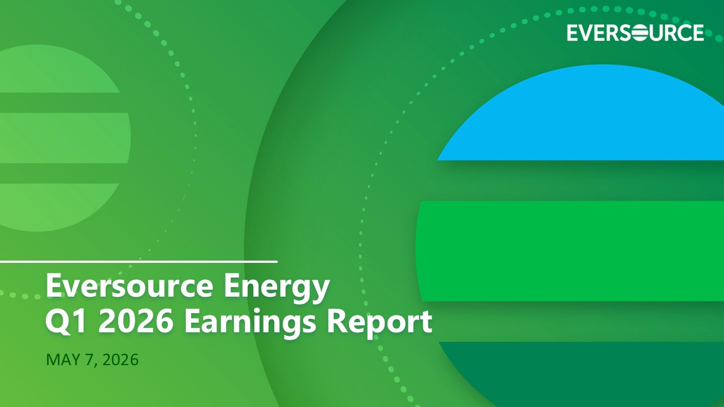
Q1 2026 EARNINGS REPORT May 7, 2026 MAY 7, 2026 Eversource Energy Q1 2026 Earnings Report

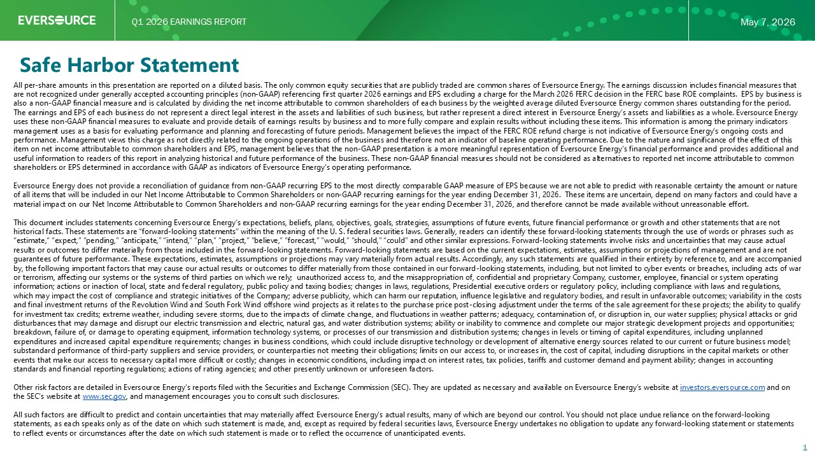
Q1 2026 EARNINGS REPORT May 7, 2026 Safe Harbor Statement 1 All per - share amounts in this presentation are reported on a diluted basis. The only common equity securities that are publicly traded are common shares of Eversource Energy. The earnings discussion includes financial measures that are not recognized under generally accepted accounting principles (non - GAAP) referencing first quarter 2026 earnings and EPS exc luding a charge for the March 2026 FERC decision in the FERC base ROE complaints. EPS by business is also a non - GAAP financial measure and is calculated by dividing the net income attributable to common shareholders of each busin ess by the weighted average diluted Eversource Energy common shares outstanding for the period. The earnings and EPS of each business do not represent a direct legal interest in the assets and liabilities of such business , b ut rather represent a direct interest in Eversource Energy’s assets and liabilities as a whole. Eversource Energy uses these non - GAAP financial measures to evaluate and provide details of earnings results by business and to more fully compare and explain results without including these items. This information is among the primary indicators management uses as a basis for evaluating performance and planning and forecasting of future periods. Management believes the im pact of the FERC ROE refund charge is not indicative of Eversource Energy's ongoing costs and performance. Management views this charge as not directly related to the ongoing operations of the business and therefore not an indicator of baseline operating performance. Due to the nature and significance of the effect of this item on net income attributable to common shareholders and EPS, management believes that the non - GAAP presentation is a more mea ningful representation of Eversource Energy's financial performance and provides additional and useful information to readers of this report in analyzing historical and future performance of the business. These non - GAAP fina ncial measures should not be considered as alternatives to reported net income attributable to common shareholders or EPS determined in accordance with GAAP as indicators of Eversource Energy's operating performance. Eversource Energy does not provide a reconciliation of guidance from non - GAAP recurring EPS to the most directly comparable GAAP measure of EPS because we are not able to predict with reasonable certainty the amount or nature of all items that will be included in our Net Income Attributable to Common Shareholders or non - GAAP recurring earnings for the year ending December 31, 2026. These items are uncertain, depend on many factors and could have a material impact on our Net Income Attributable to Common Shareholders and non - GAAP recurring earnings for the year ending Decemb er 31, 2026, and therefore cannot be made available without unreasonable effort. This document includes statements concerning Eversource Energy’s expectations, beliefs, plans, objectives, goals, strategies, as sumptions of future events, future financial performance or growth and other statements that are not historical facts. These statements are “forward - looking statements” within the meaning of the U. S. federal securities laws. Gen erally, readers can identify these forward - looking statements through the use of words or phrases such as “estimate,” “expect,” “pending,” “anticipate,” “intend,” “plan,” “project,” “believe,” “forecast,” “would,” “should,” “could” an d other similar expressions. Forward - looking statements involve risks and uncertainties that may cause actual results or outcomes to differ materially from those included in the forward - looking statements. Forward - looking statements are b ased on the current expectations, estimates, assumptions or projections of management and are not guarantees of future performance. These expectations, estimates, assumptions or projections may vary materially from actual r esu lts. Accordingly, any such statements are qualified in their entirety by reference to, and are accompanied by, the following important factors that may cause our actual results or outcomes to differ materially from those contained i n o ur forward - looking statements, including, but not limited to cyber events or breaches, including acts of war or terrorism, affecting our systems or the systems of third parties on which we rely; unauthorized access to, and the misapprop riation of, confidential and proprietary Company, customer, employee, financial or system operating information; actions or inaction of local, state and federal regulatory, public policy and taxing bodies; changes in laws, re gul ations, Presidential executive orders or regulatory policy, including compliance with laws and regulations, which may impact the cost of compliance and strategic initiatives of the Company; adverse publicity, which can harm our reput ati on, influence legislative and regulatory bodies, and result in unfavorable outcomes; variability in the costs and final investment returns of the Revolution Wind and South Fork Wind offshore wind projects as it relates to the purchase pri ce post - closing adjustment under the terms of the sale agreement for these projects; the ability to qualify for investment tax credits; extreme weather, including severe storms, due to the impacts of climate change, and fluctuations in weather patterns; adequacy, contamination of, or disruption in, our water supplies; physical attacks or grid disturbances that may damage and disrupt our electric transmission and electric, natural gas, and water distribution systems; ab ility or inability to commence and complete our major strategic development projects and opportunities; breakdown, failure of, or damage to operating equipment, information technology systems, or processes of our transmission and di stribution systems; changes in levels or timing of capital expenditures, including unplanned expenditures and increased capital expenditure requirements; changes in business conditions, which could include disruptive t ech nology or development of alternative energy sources related to our current or future business model; substandard performance of third - party suppliers and service providers, or counterparties not meeting their obligations; limits on our access to, or increases in, the cost of capital, including disruptions in the capital markets or other events that make our access to necessary capital more difficult or costly; changes in economic conditions, including impact o n i nterest rates, tax policies, tariffs and customer demand and payment ability; changes in accounting standards and financial reporting regulations; actions of rating agencies; and other presently unknown or unforeseen factors. Other risk factors are detailed in Eversource Energy’s reports filed with the Securities and Exchange Commission (SEC). They are updated as necessary and available on Eversource Energy’s website at investors.eversource.com and on the SEC’s website at www.sec.gov , and management encourages you to consult such disclosures. All such factors are difficult to predict and contain uncertainties that may materially affect Eversource Energy’s actual res ult s, many of which are beyond our control. You should not place undue reliance on the forward - looking statements, as each speaks only as of the date on which such statement is made, and, except as required by federal securities la ws, Eversource Energy undertakes no obligation to update any forward - looking statement or statements to reflect events or circumstances after the date on which such statement is made or to reflect the occurrence of unanticipat ed events.

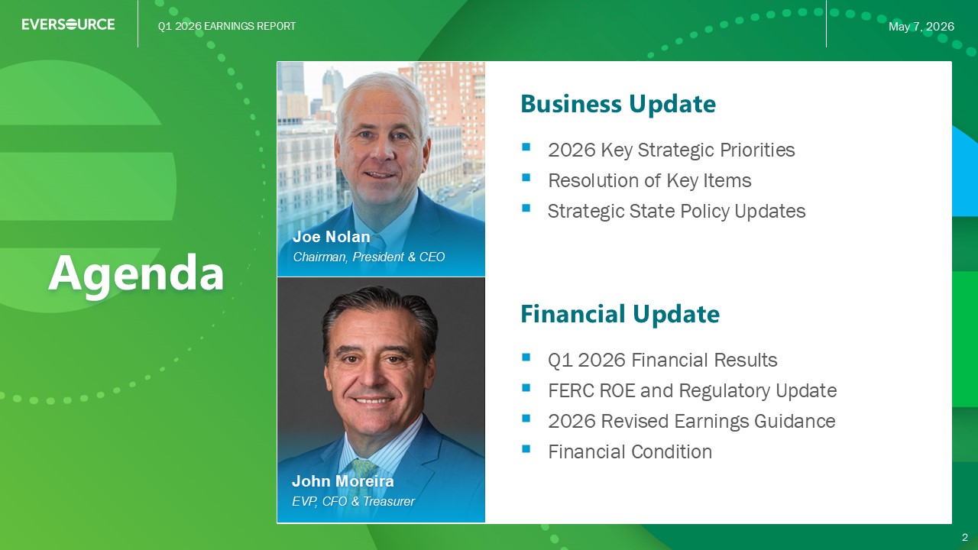
Q1 2026 EARNINGS REPORT May 7, 2026 Agenda Business Update ▪ 2026 Key Strategic Priorities ▪ Resolution of Key Items ▪ Strategic State Policy Updates 2 Joe Nolan Chairman, President & CEO Financial Update ▪ Q1 2026 Financial Results ▪ FERC ROE and Regulatory Update ▪ 2026 Revised Earnings Guidance ▪ Financial Condition John Moreira EVP, CFO & Treasurer


Q1 2026 EARNINGS REPORT May 7, 2026 Q1 2026 EARNINGS REPORT 3 CHAIRMAN, PRESIDENT & CHIEF EXECUTIVE OFFICER Joe Nolan Business Update

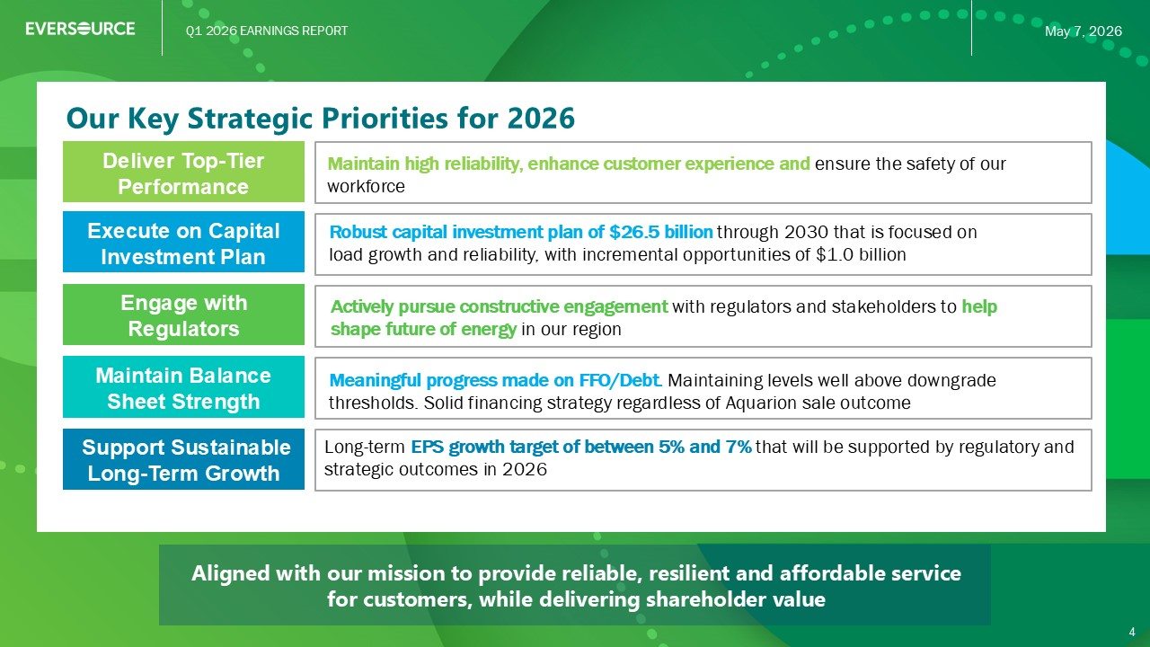
Q1 2026 EARNINGS REPORT May 7, 2026 Aligned with our mission to provide reliable, resilient and affordable service for customers, while delivering shareholder value Our Key Strategic Priorities for 2026 Long - term EPS growth target of between 5% and 7% that will be supported by regulatory and strategic outcomes in 2026 Execute on Capital Investment Plan Maintain Balance Sheet Strength Deliver Top - Tier Performance Robust capital investment plan of $26.5 billion through 2030 that is focused on load growth and reliability, with incremental opportunities of $1.0 billion Meaningful progress made on FFO/Debt. Maintaining levels well above downgrade thresholds. Solid financing strategy regardless of Aquarion sale outcome Maintain high reliability, enhance customer experience and ensure the safety of our workforce Engage with Regulators Actively pursue constructive engagement with regulators and stakeholders to help shape future of energy in our region Support Sustainable Long - Term Growth 4

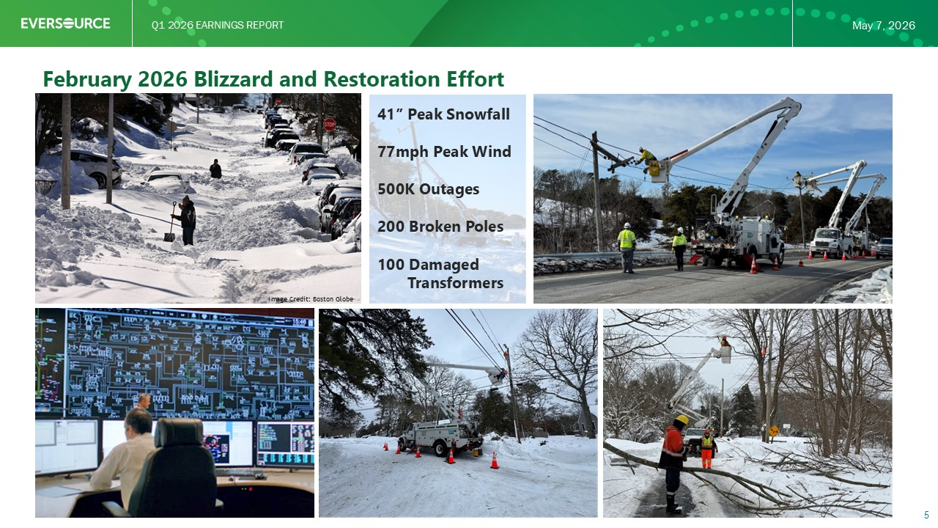
Q1 2026 EARNINGS REPORT May 7, 2026 February 2026 Blizzard and Restoration Effort 5 41” Peak Snowfall 77mph Peak Wind 500K Outages 200 Broken Poles 100 Damaged Transformers Image Credit: Boston Globe

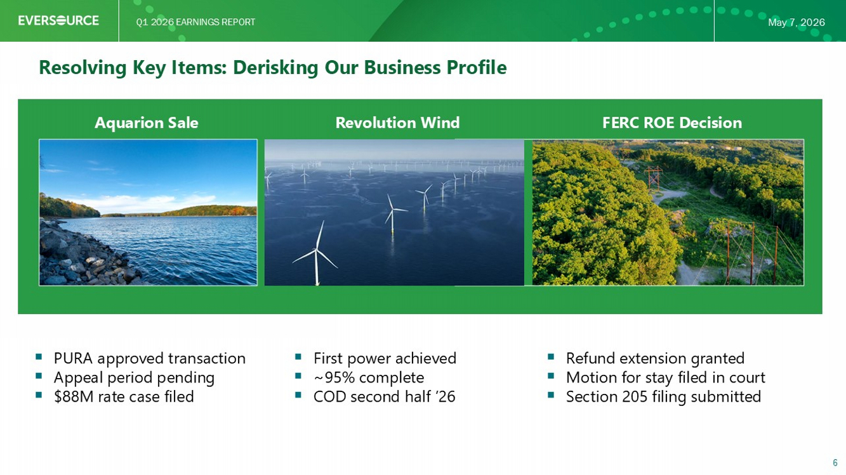
Q1 2026 EARNINGS REPORT May 7, 2026 Resolving Key Items: Derisking Our Business Profile 6 Aquarion Sale Revolution Wind FERC ROE Decision ▪ First power achieved ▪ ~95% complete ▪ Second Half ’26 COD ▪ PURA approved transaction ▪ Appeal period pending ▪ $88M rate case filed ▪ Refund extension granted ▪ Motion for stay filed in court ▪ Section 205 filing submitted

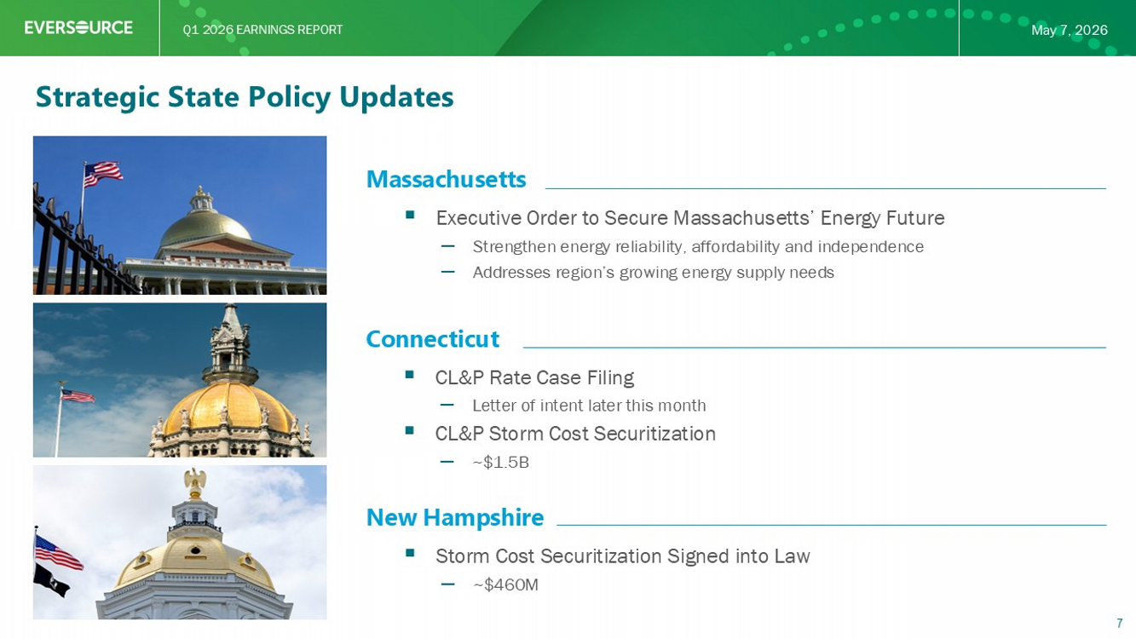
Q1 2026 EARNINGS REPORT May 7, 2026 Strategic State Policy Updates Massachusetts ▪ Executive Order to Secure Massachusetts’ Energy Future – Strengthen energy reliability, affordability and independence – Addresses region’s growing energy supply needs Connecticut ▪ CL&P Rate Case Filing – Letter of intent to be filed soon ▪ CL&P Storm Cost Securitization – ~$1.5B New Hampshire ▪ Storm Cost Securitization Signed into Law – ~$460M 7


Q1 2026 EARNINGS REPORT May 7, 2026 Q1 2026 EARNINGS REPORT 8 EXECUTIVE VICE PRESIDENT, CHIEF FINANCIAL OFFICER & TREASURER John Moreira Financial Update

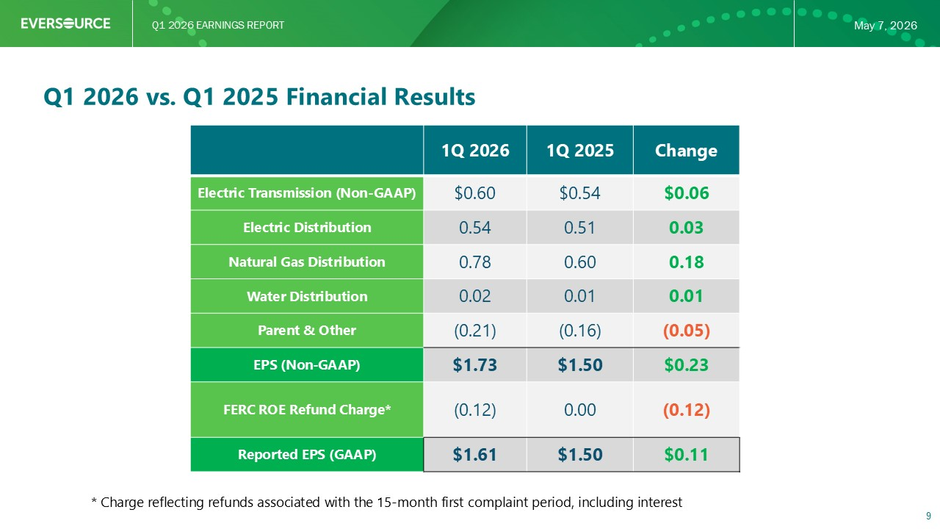
Q1 2026 EARNINGS REPORT May 7, 2026 Q1 2026 vs. Q1 2025 Financial Results 9 Change 1Q 2025 1Q 2026 $0.06 $0.54 $0.60 Electric Transmission (Non - GAAP) 0.03 0.51 0.54 Electric Distribution 0.18 0.60 0.78 Natural Gas Distribution 0.01 0.01 0.02 Water Distribution (0.05) (0.16) (0.21) Parent & Other $0.23 $1.50 $1.73 EPS (Non - GAAP) (0.12) 0.00 (0.12) FERC ROE Refund Charge* $0.11 $1.50 $1.61 Reported EPS (GAAP) * Charge reflecting refunds associated with the 15 - month first complaint period, including interest

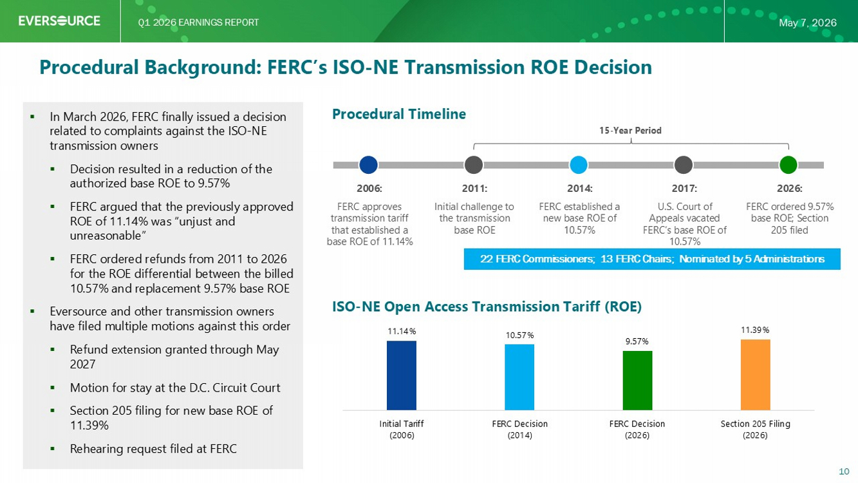
Q1 2026 EARNINGS REPORT May 7, 2026 Procedural Background: FERC’s ISO - NE Transmission ROE Decision Procedural Timeline ▪ In March 2026, FERC finally issued a decision related to complaints against the ISO - NE transmission owners ▪ Decision resulted in a reduction of the authorized base ROE to 9.57% ▪ FERC argued that the previously approved ROE of 11.14% was “unjust and unreasonable” ▪ FERC ordered refunds from 2011 to 2026 for the ROE differential between the billed 10.57% and replacement 9.57% base ROE ▪ Eversource and other transmission owners have filed multiple motions against this order ▪ Re fund extension granted through May 2027 ▪ Motion for stay at the D.C. Circuit Court ▪ Section 205 filing for new base ROE of 11.39% ▪ Rehearing request filed 10 ISO - NE Open Access Transmission Tariff (ROE) 11.14% 10.57% 9.57% 11.39% Initial Tariff (2006) FERC Decision (2014) FERC Decision (2026) Section 205 Filing (2026) 2006: FERC approves transmission tariff that established a base ROE of 11.14% 2011: Initial challenge to the transmission base ROE 2014: FERC established a new base ROE of 10.57% 2017: U.S. Court of Appeals vacated FERC’s base ROE of 10.57% 2026: FERC ordered 9.57% base ROE; Section 205 filed 15 - Year Period 22 FERC Commissioners; 13 FERC Chairs; Nominated by 5 Administrations

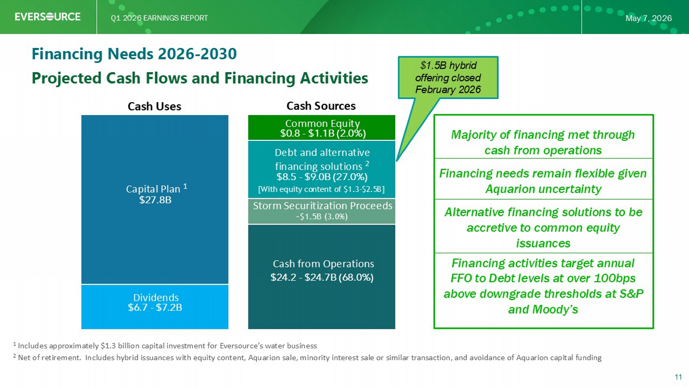
Q1 2026 EARNINGS REPORT May 7, 2026 $6.7 - $7.2B $27.8B $24.2 - $24.7B (68.0%) $8.5 - $9.0B (27.0%) $0.8 - $1.1B (2.0%) Projected Cash Flows and Financing Activities 11 Financing Needs 2026 - 2030 Cash Uses Cash Sources Common Equity Debt and alternative financing solutions 2 Cash from Operations Dividends Capital Plan 1 1: Includes approximately $1.3 billion capital investment for Eversource’s water business 2: Net of retirement. Includes hybrid issuances with equity content, Aquarion sale, minority interest sale or similar transaction, and avoidance of Aquarion capital funding Majority of financing met through cash from operations. Financing needs remain flexible given Aquarion uncertainty Alternative financing solutions to be accretive to common equity issuances Financing activities target annual FFO - Debt levels at over 100bps above downgrade thresholds at S&P and Moody’s Storm Securitization Proceeds [With equity content of $1.3 - $2.5B] ~$1.5B (3.0%) $1.5B hybrid offering closed February 2026

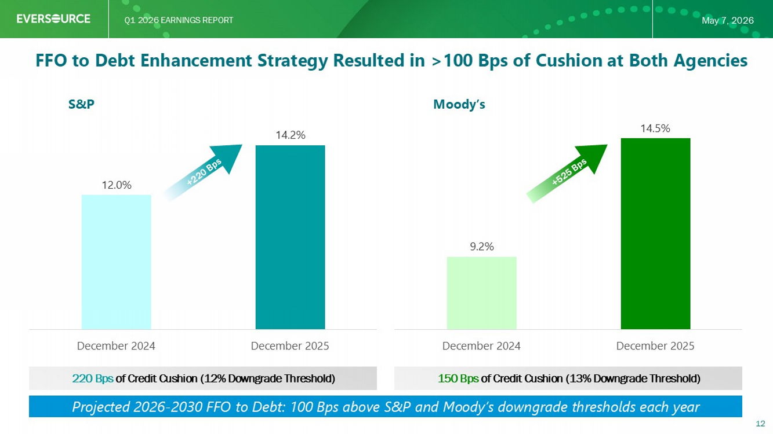
Q1 2026 EARNINGS REPORT May 7, 2026 FFO : Debt Enhancement Strategy Resulted in >100 Bps of Cushion at Both Agencies S&P Moody’s 12.0% 14.2% December 2024 December 2025 9.2% 14.5% December 2024 December 2025 220 Bps of Credit Cushion (12% Downgrade Threshold) 150 Bps of Credit Cushion (13% Downgrade Threshold) 12 Projected 2026 - 2030 FFO to Debt: 100 Bps above S&P and Moody’s downgrade thresholds each year

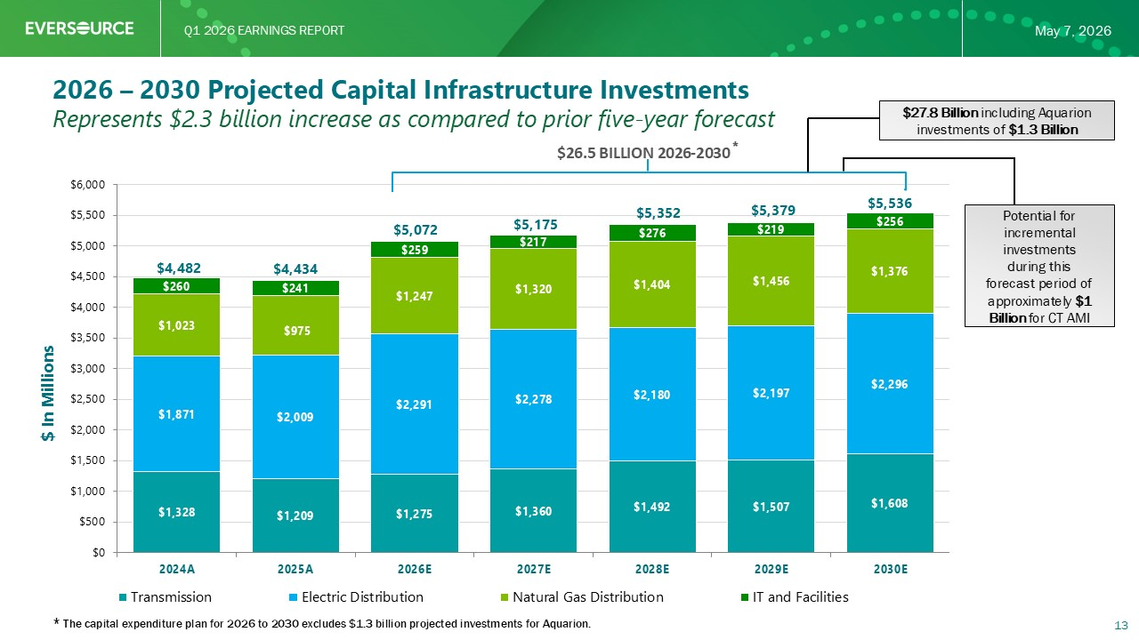
Q1 2026 EARNINGS REPORT May 7, 2026 $1,328 $1,209 $1,275 $1,360 $1,492 $1,507 $1,608 $1,871 $2,009 $2,291 $2,278 $2,180 $2,197 $2,296 $1,023 $975 $1,247 $1,320 $1,404 $1,456 $1,376 $260 $241 $259 $217 $276 $219 $256 $4,482 $4,434 $5,072 $5,175 $5,352 $5,379 $5,536 $0 $500 $1,000 $1,500 $2,000 $2,500 $3,000 $3,500 $4,000 $4,500 $5,000 $5,500 $6,000 2024A 2025A 2026E 2027E 2028E 2029E 2030E Transmission Electric Distribution Natural Gas Distribution IT and Facilities $ In Millions $26.5 BILLION 2026 - 2030 * 2026 – 2030 Projected Capital Infrastructure Investments 13 * The capital expenditure plan for 2026 to 2030 excludes $1.3 billion projected investments for Aquarion. Represents $2.3 billion increase as compared to prior five - year forecast $27.8 Billion including Aquarion investments of $1.3 Billion Potential for incremental investments during this forecast period of approximately $1 Billion for CT AMI

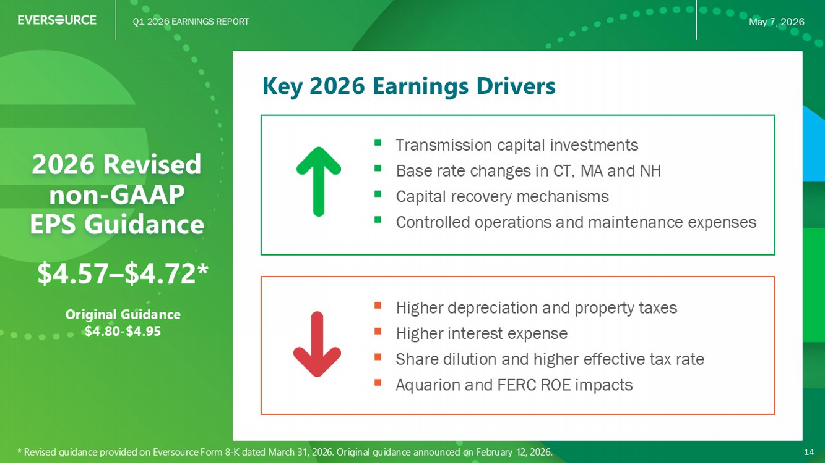
Q1 2026 EARNINGS REPORT May 7, 2026 Key 2026 Earnings Drivers 2026 Revised EPS Guidance ▪ Transmission capital investments ▪ Base rate changes in CT, MA and NH ▪ Capital recovery mechanisms ▪ Controlled operations and maintenance expenses 14 ▪ Higher depreciation and property taxes ▪ Higher interest expense ▪ Share dilution and higher effective tax rate ▪ Aquarion and FERC ROE impacts $4.57 – $4.72* Original Guidance $4.80 - $4.95 * Revised guidance provided on Eversource Form 8 - K dated March 31, 2026 . Original guidance announced on February 12, 2026.

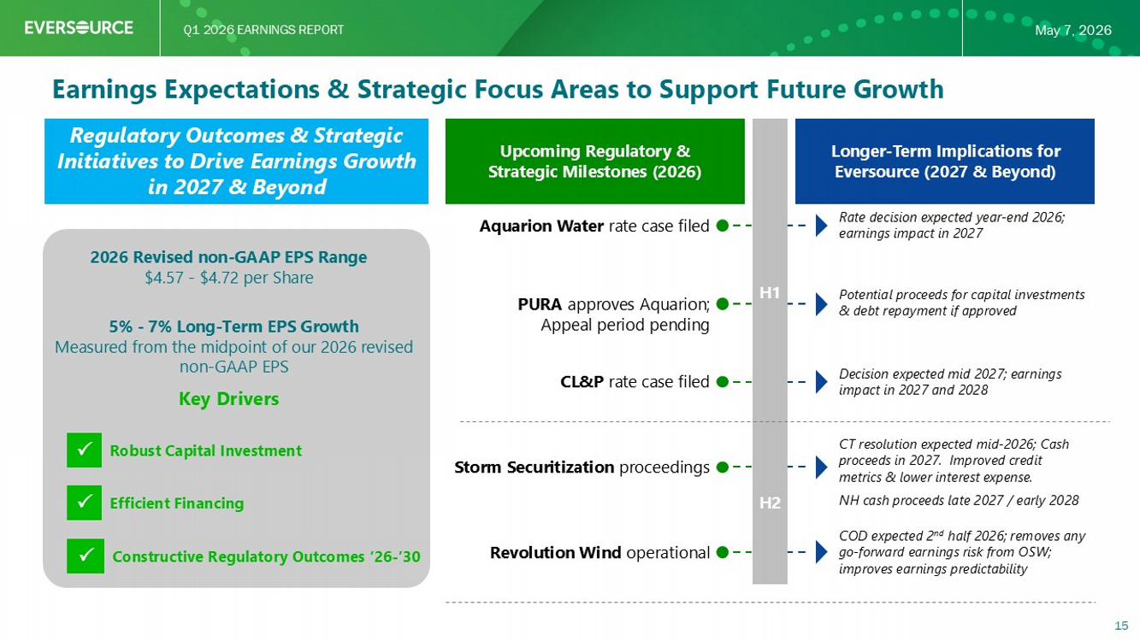
Q1 2026 EARNINGS REPORT May 7, 2026 Earnings Expectations & Strategic Focus Areas to Support Future Growth Upcoming Regulatory & Strategic Milestones (2026) Regulatory Outcomes & Strategic Initiatives to Drive Earnings Growth in 2027 & Beyond 2026 Revised EPS Range $4. 57 - $4.72 per Share 5% - 7% Long - Term EPS Growth Measured from the midpoint of our 2026 revised non - GAAP EPS Key Drivers Robust Capital Investment Efficient Financing Constructive Regulatory Outcomes ’26 - ’30 Longer - Term Implications for Eversource (2027 & Beyond) Aquarion Water rate case filed CL&P rate case filed PURA approves Aquarion; Appeal period pending Storm Securitization proceedings Revolution Wind operational Rate decision expected year - end 2026; earnings impact in 2027 Potential proceeds for capital investments & debt repayment if approved Decision expected mid 2027; earnings impact in 2027 and 2028 CT resolution expected mid - 2026; Cash proceeds in 2027. Improved credit metrics & lower interest expense. NH cash proceeds late 2027 / early 2028 COD expected 2 nd half 2026; removes any go - forward earnings risk from OSW; improves earnings predictability 15 H1 H2


Q1 2026 EARNINGS REPORT May 7, 2026 Q & A 16


Q1 2026 EARNINGS REPORT May 7, 2026 Appendix 17

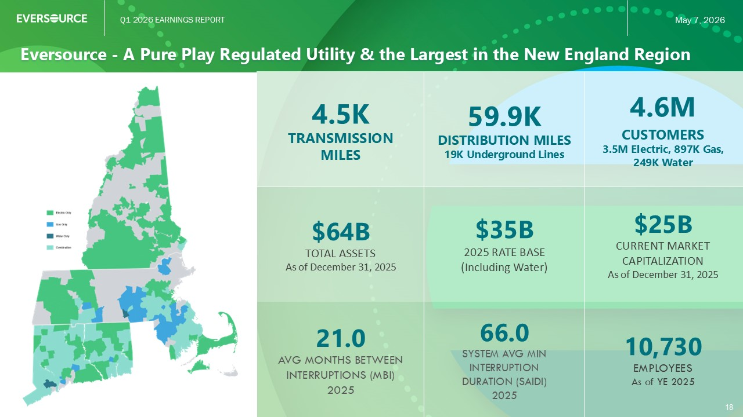
Q1 2026 EARNINGS REPORT May 7, 2026 Eversource - A Pure Play Regulated Utility & the Largest in the New England Region 18 4.6M CUSTOMERS 3.5M Electric, 897K Gas, 249K Water 59.9K DISTRIBUTION MILES 19K Underground Lines 4.5K TRANSMISSION MILES $25B CURRENT MARKET CAPITALIZATION As of December 31, 2025 $35B 2025 RATE BASE (Including Water) $64B TOTAL ASSETS As of December 31, 2025 10,730 EMPLOYEES As of YE 2025 66.0 SYSTEM AVG MIN INTERRUPTION DURATION (SAIDI) 2025 21.0 AVG MONTHS BETWEEN INTERRUPTIONS (MBI) 2025

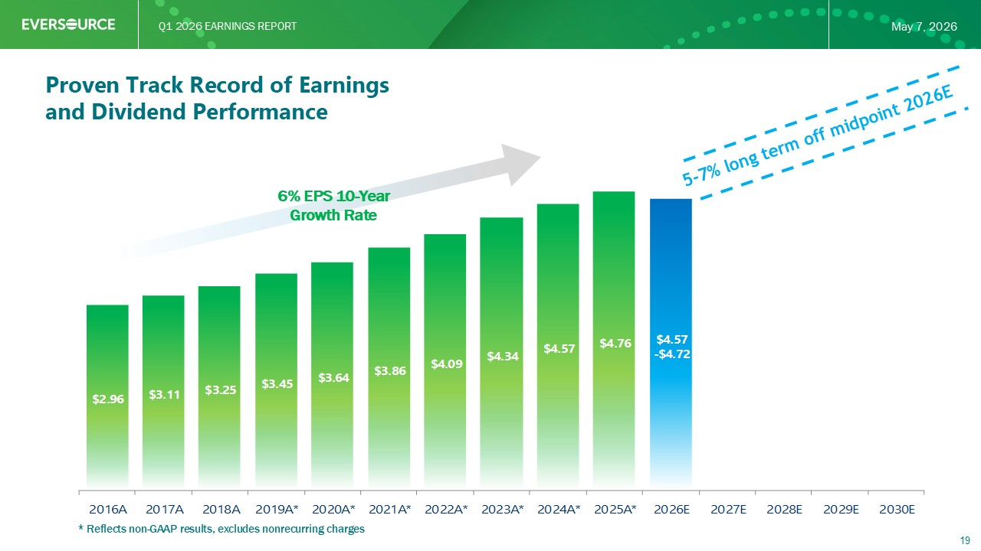
Q1 2026 EARNINGS REPORT May 7, 2026 $2.96 $3.11 $3.25 $3.45 $3.64 $3.86 $4.09 $4.34 $4.57 $4.76 $4.57 - $4.72 2016A 2017A 2018A 2019A* 2020A* 2021A* 2022A* 2023A* 2024A* 2025A* 2026E 2027E 2028E 2029E 2030E * Reflects non - GAAP results, excludes nonrecurring charges 19 Proven Track Record of Earnings and Dividend Performance 6% EPS 10 - Year Growth Rate

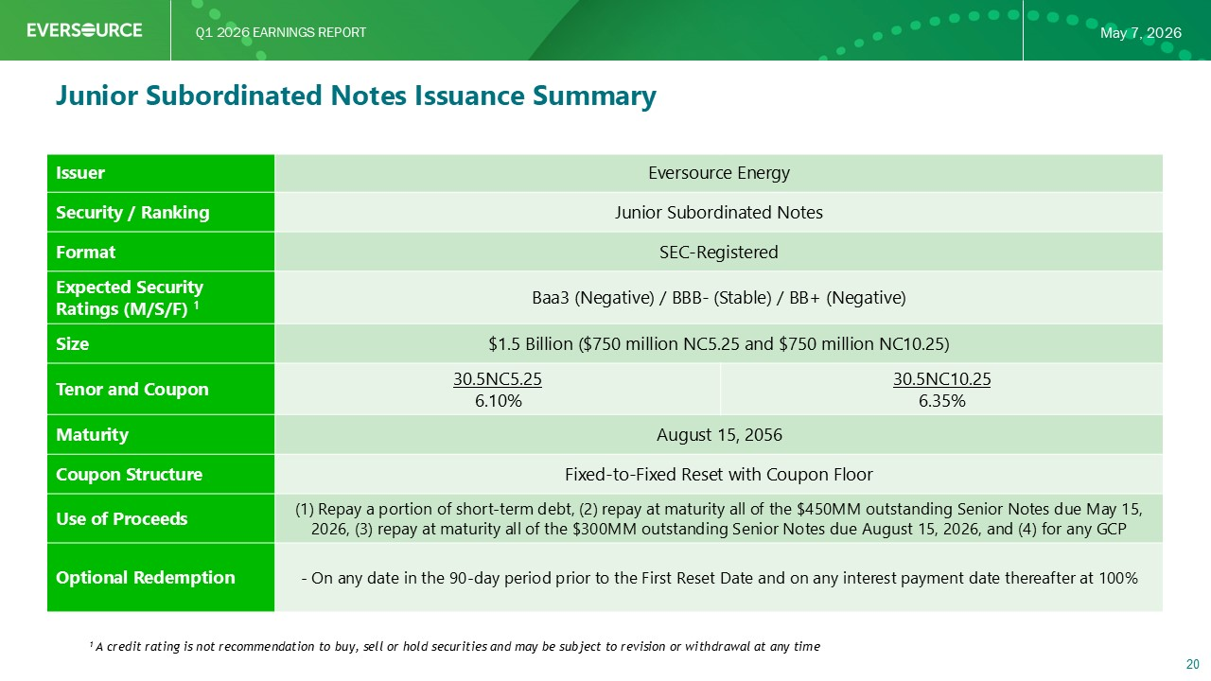
Q1 2026 EARNINGS REPORT May 7, 2026 Eversource Energy Issuer Junior Subordinated Notes Security / Ranking SEC - Registered Format Baa3 (Negative) / BBB - (Stable) / BB+ (Negative) Expected Security Ratings (M/S/F) 1 $1.5 Billion ($750 million NC5.25 and $750 million NC10.25) Size 30.5NC10.25 6.35% 30.5NC5.25 6.10% Tenor and Coupon August 15, 2056 Maturity Fixed - to - Fixed Reset with Coupon Floor Coupon Structure (1) Repay a portion of short - term debt, (2) repay at maturity all of the $450MM outstanding Senior Notes due May 15, 2026, (3) repay at maturity all of the $300MM outstanding Senior Notes due August 15, 2026, and (4) for any GCP Use of Proceeds - On any date in the 90 - day period prior to the First Reset Date and on any interest payment date thereafter at 100% Optional Redemption 20 1 A credit rating is not recommendation to buy, sell or hold securities and may be subject to revision or withdrawal at any tim e Junior Subordinated Notes Issuance Summary

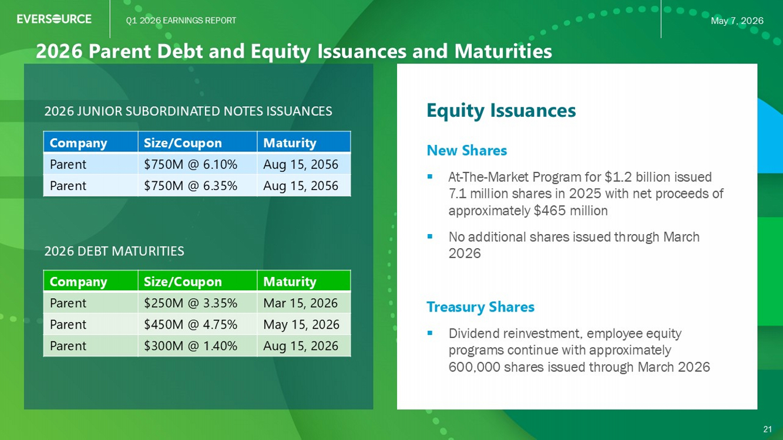
Q1 2026 EARNINGS REPORT May 7, 2026 2026 Parent Debt and Equity Issuances and Maturities 21 Equity Issuances New Shares ▪ At - The - Market Program for $1.2 billion issued 7.1 million shares in 2025 with net proceeds of approximately $ 465 million ▪ No additional shares issued through March 2026 Treasury Shares ▪ Dividend reinvestment, employee equity programs continue with approximately 600 thousand shares issued through March 2026 2026 DEBT MATURITIES Maturity Size/Coupon Company Mar 15, 2026 $250M @ 3.35% Parent May 15, 2026 $450M @ 4.75% Parent Aug 15, 2026 $300M @ 1.40% Parent 21 2026 JUNIOR SUBORDINATED NOTES ISSUANCES Maturity Size/Coupon Company Aug 15, 2056 $750M @ 6.10% Parent Aug 15, 2056 $750M @ 6.35% Parent


Q1 2026 EARNINGS REPORT May 7, 2026 For the 6 th consecutive year received the HIRE Vets award (Honoring Investments in Recruiting and Employing American Military Veterans). For the first time Eversource achieved the Platinum level, the highest recognition from the US Department of Labor. Named as one of America’s Climate Leaders by USA TODAY and Statista for the 3 rd year in a row. Ranked #1 among energy companies and utilities nationwide for the highest core emissions reduction year - over - year. For the 7th year in a row Eversource was recognized in Newsweek’s list of America’s Most Responsible Companies based on our corporate social sustainability performance and reputation. Eversource was recognized in Newsweek’s list of the Most Trustworthy Companies In America for companies that demonstrate leadership in ethical business practices and have built strong trust among stakeholders. Included as a constituent of the FTSE4Good Index Series, designed to identify companies that demonstrate strong environmental, social and governance practices measured against globally recognized standards. Eversource has been recognized in the 2025 Healthiest 100 Workplaces in America, an awards program created to honor people - first organizations that prioritize the well - being of their employee population. 22 Eversource Recognition

